**Write a template to create a Storage Account with SKU restrictions, encryption enabled and allow https access only.**

**Azure Storage**

Attached Arm Template



Sku details restrictions encryption enabled and allow https access only.

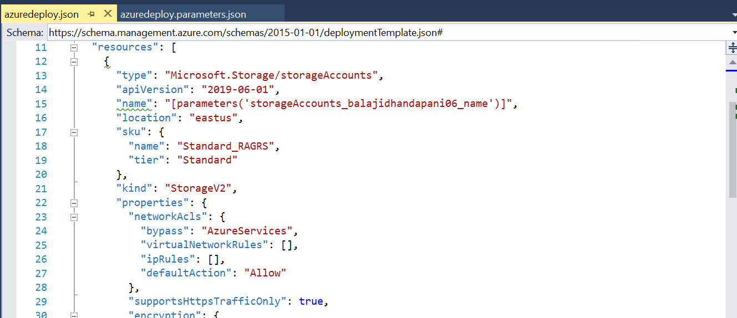

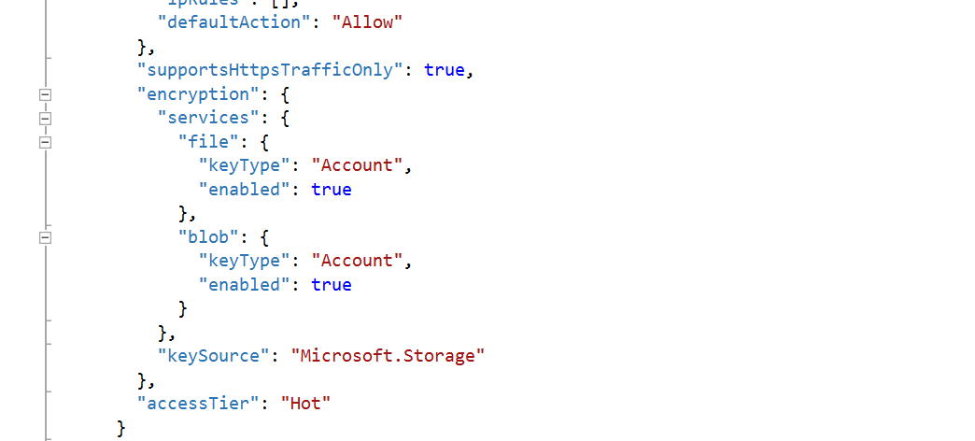

Deployment steps:

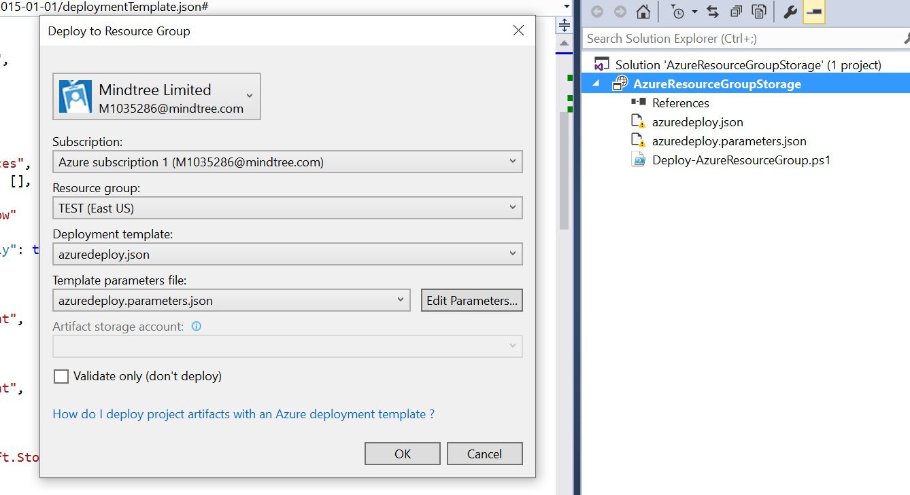

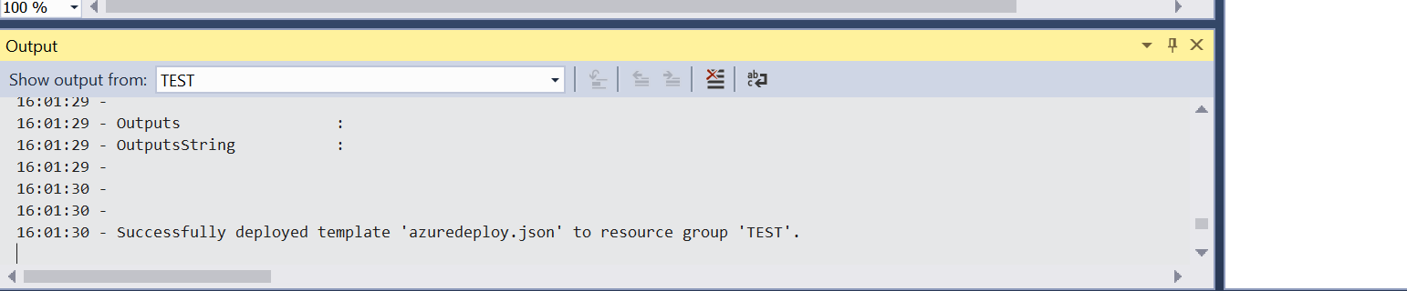

After deployment from visual studio, storage account is created as below.

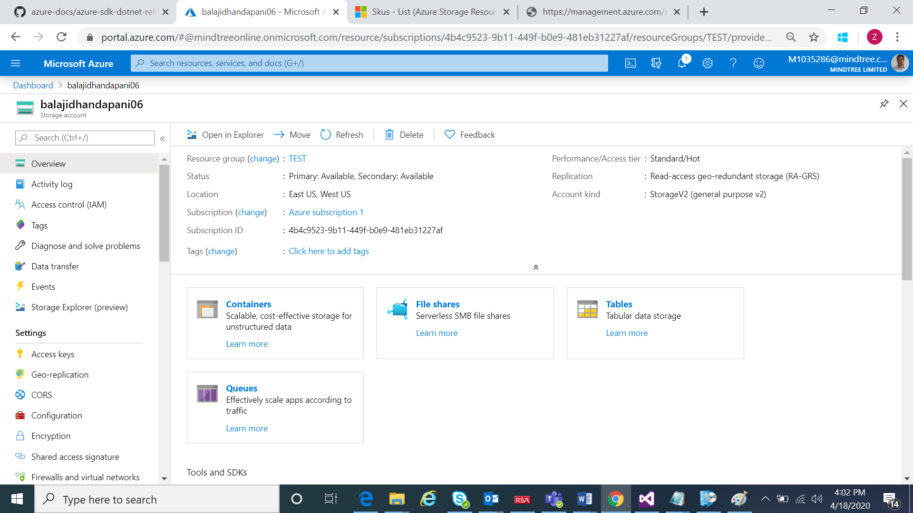

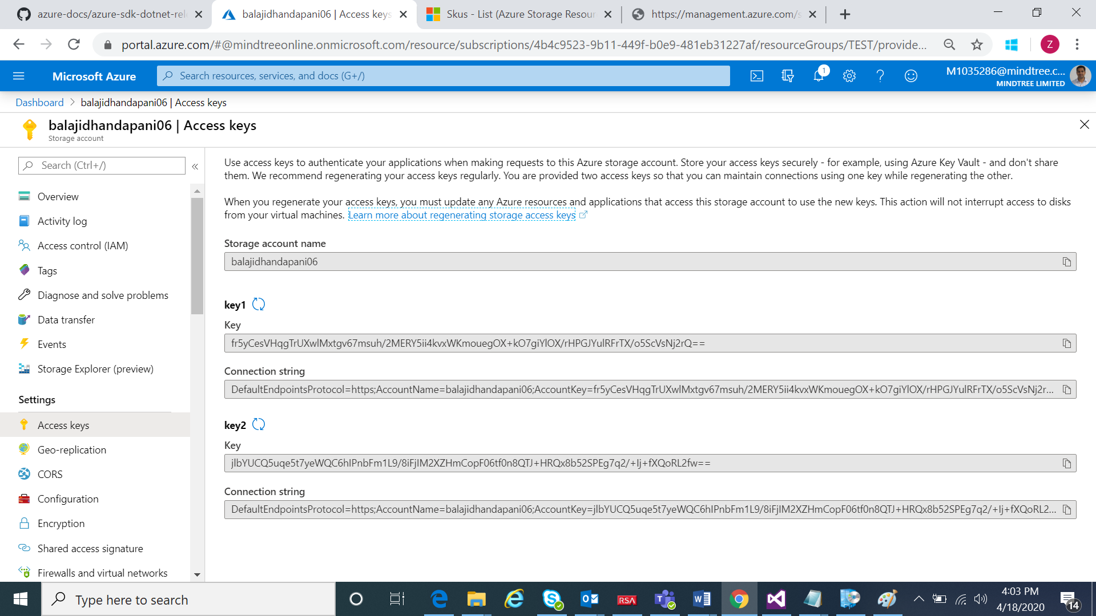

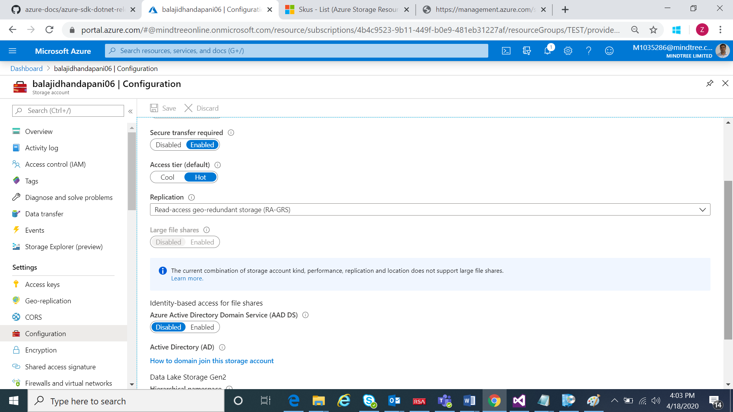

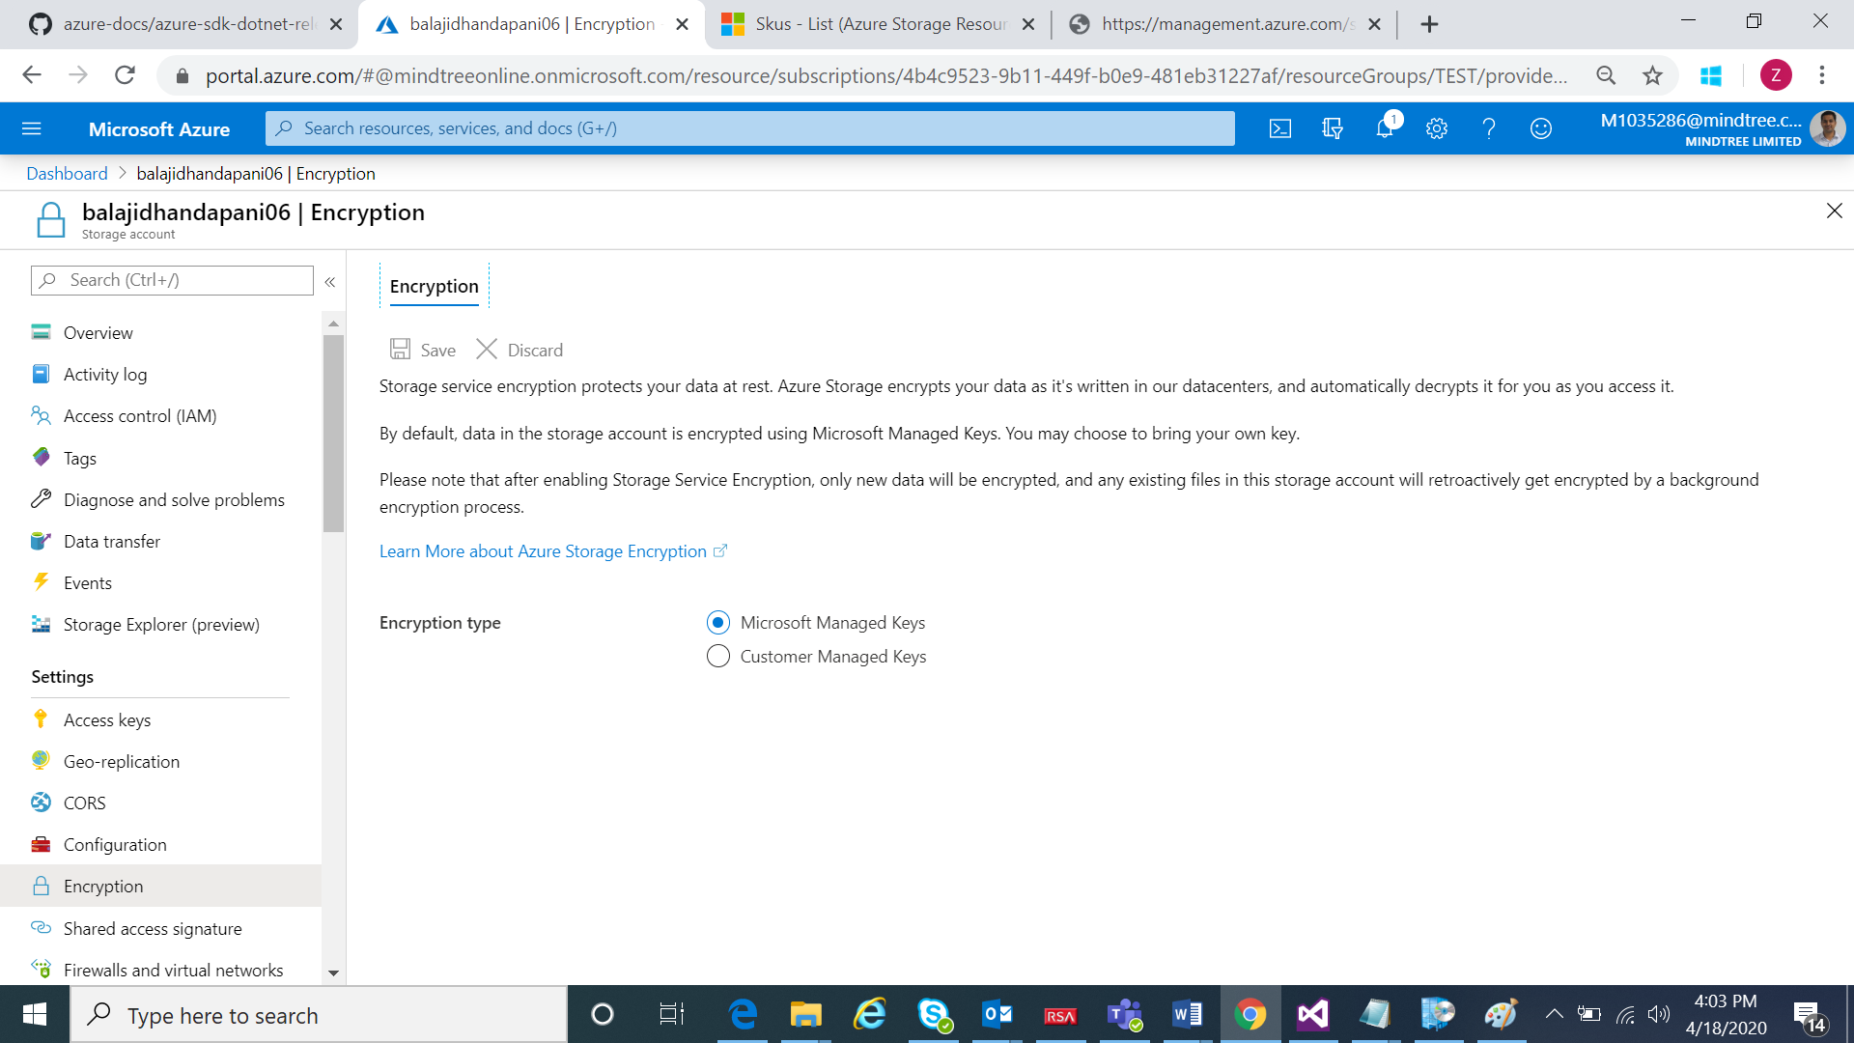

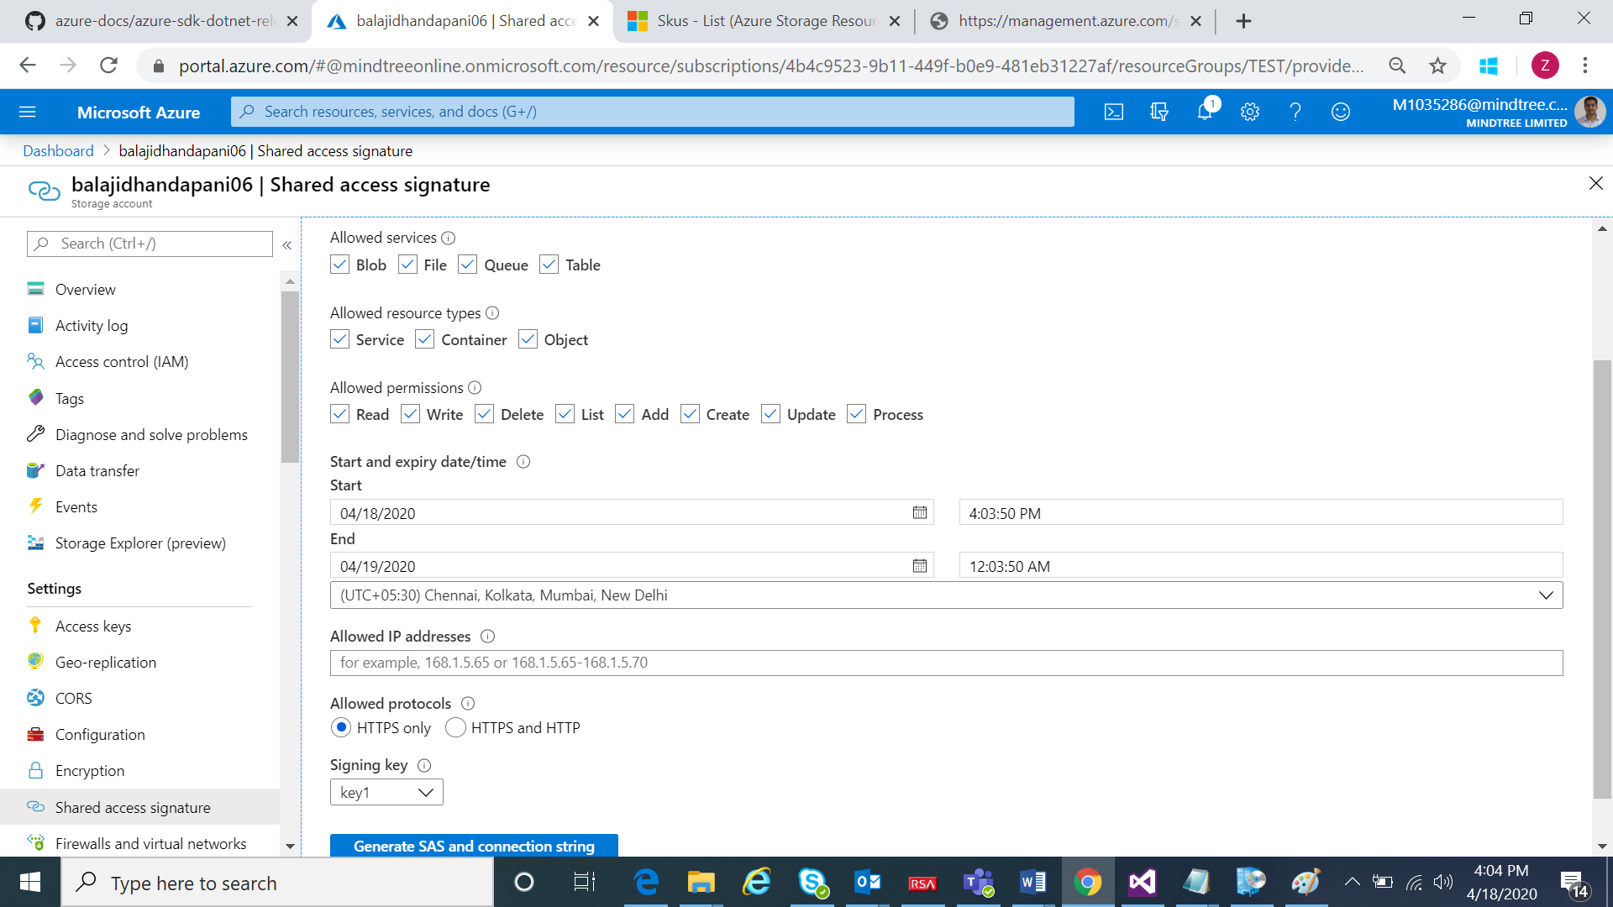

**Case Study 2:**

1. **Create an ARM Template for a virtual network with subnets and Network Security Group with Inbound Outbound rules**

**Network Security group creation ARM template**





**Screen shot after ARM deployment**

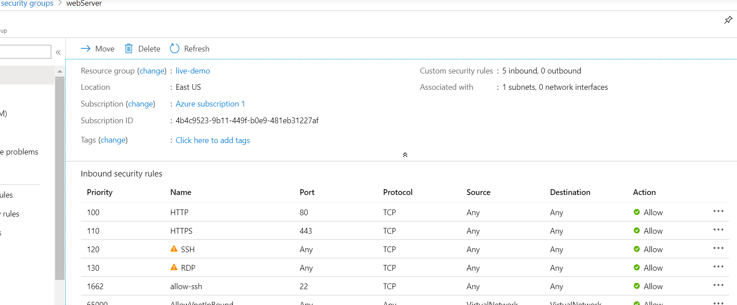

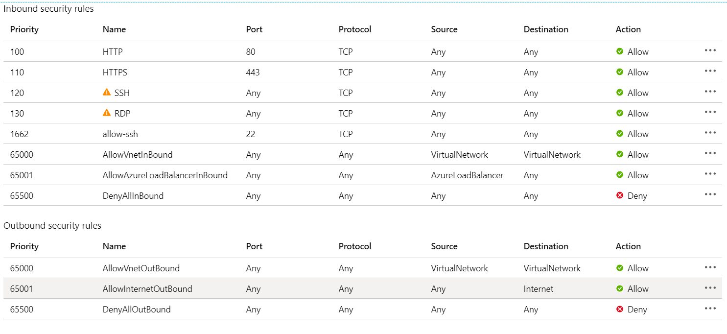

Creation of Virtual network.

ARM Template:



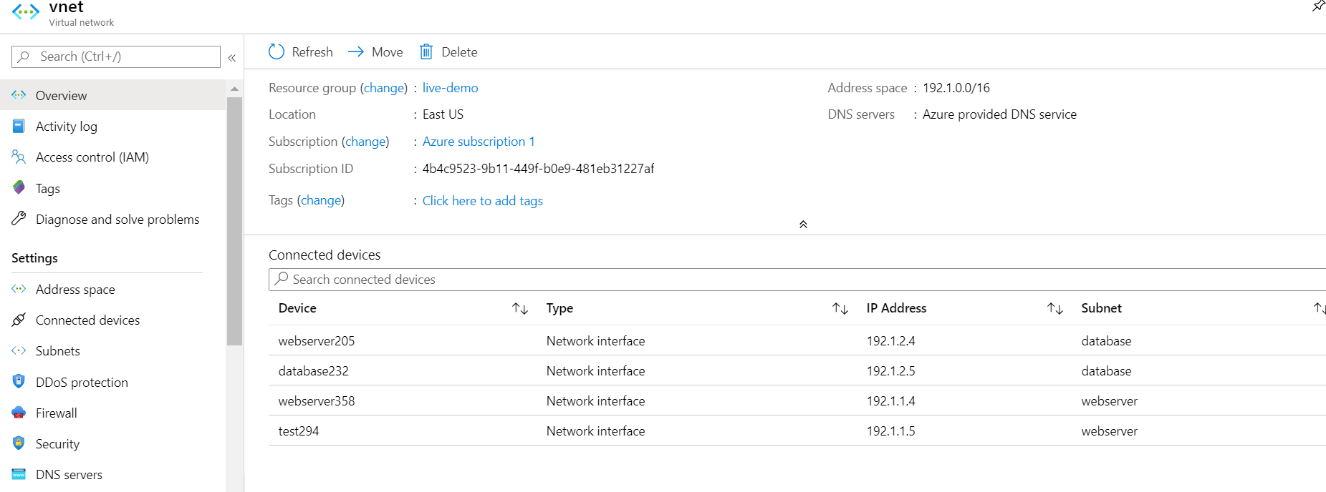

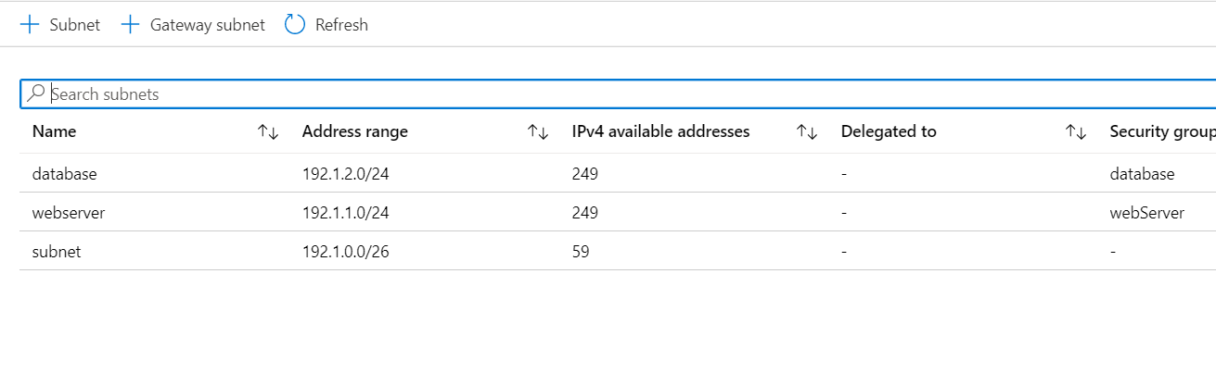

1. Write an ARM Template to deploy a windows VM using the existing VNets and NSGs



Virtual machine is created below

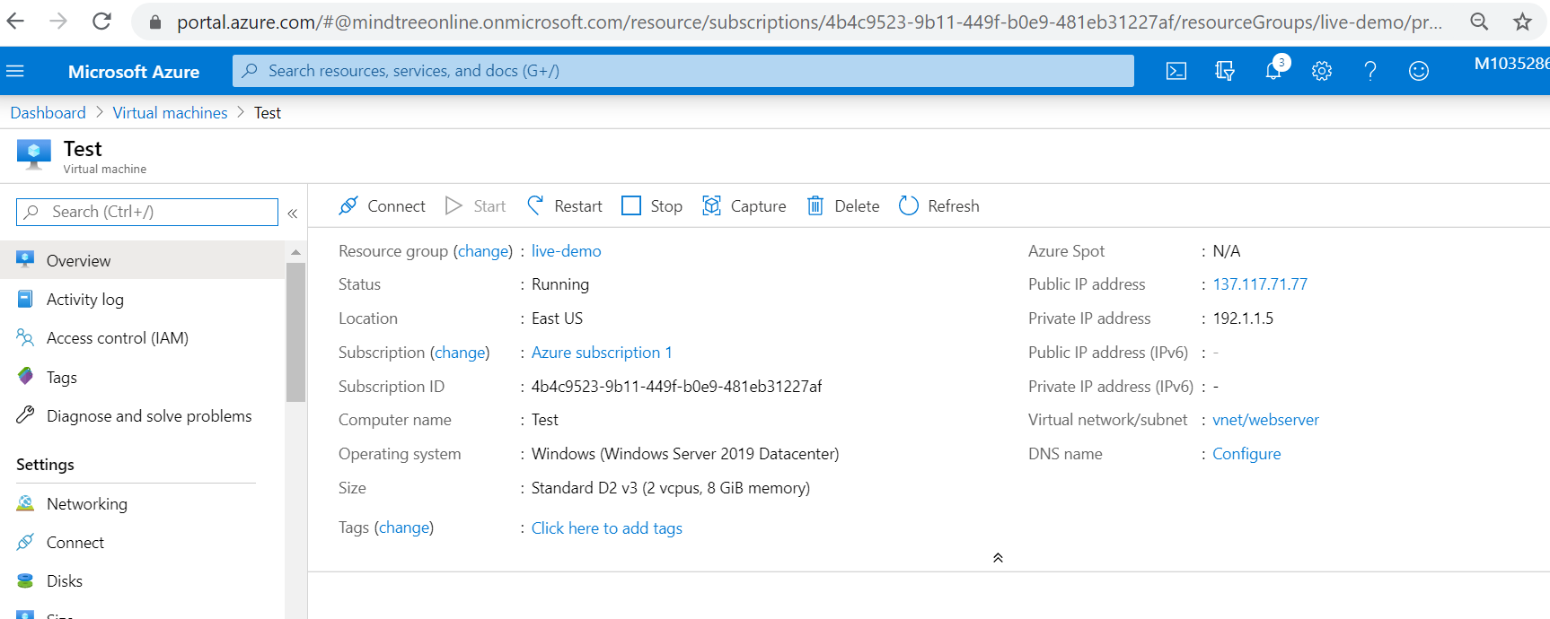

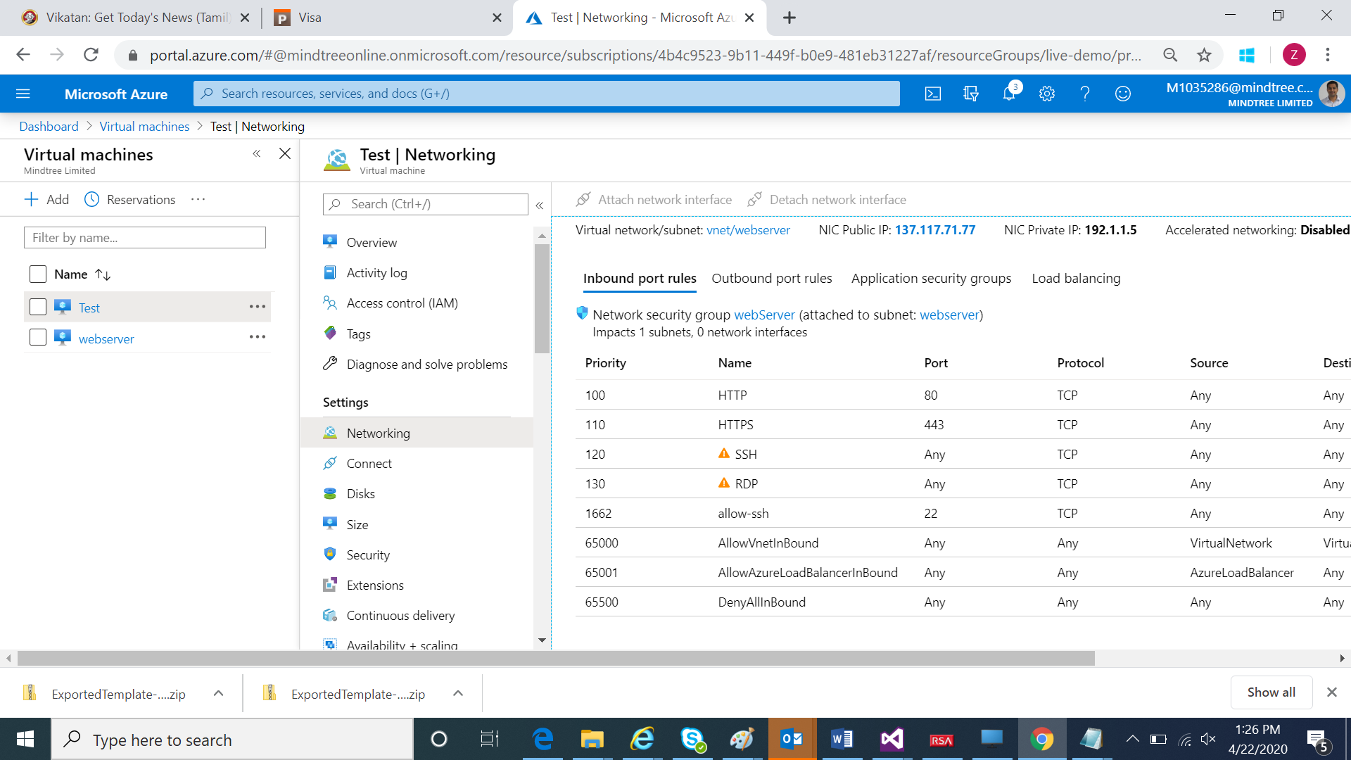

Connecting to remote desktop by RDP

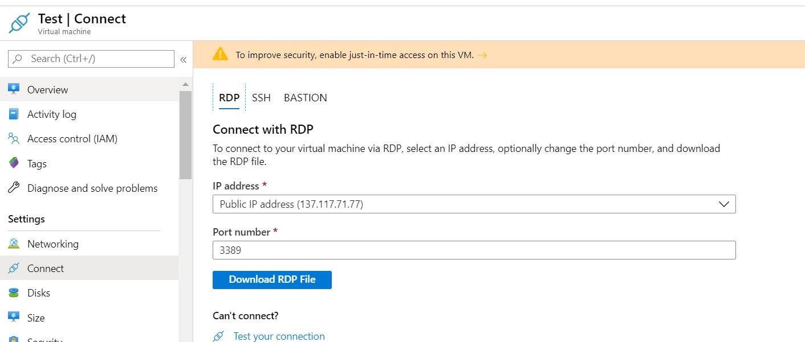

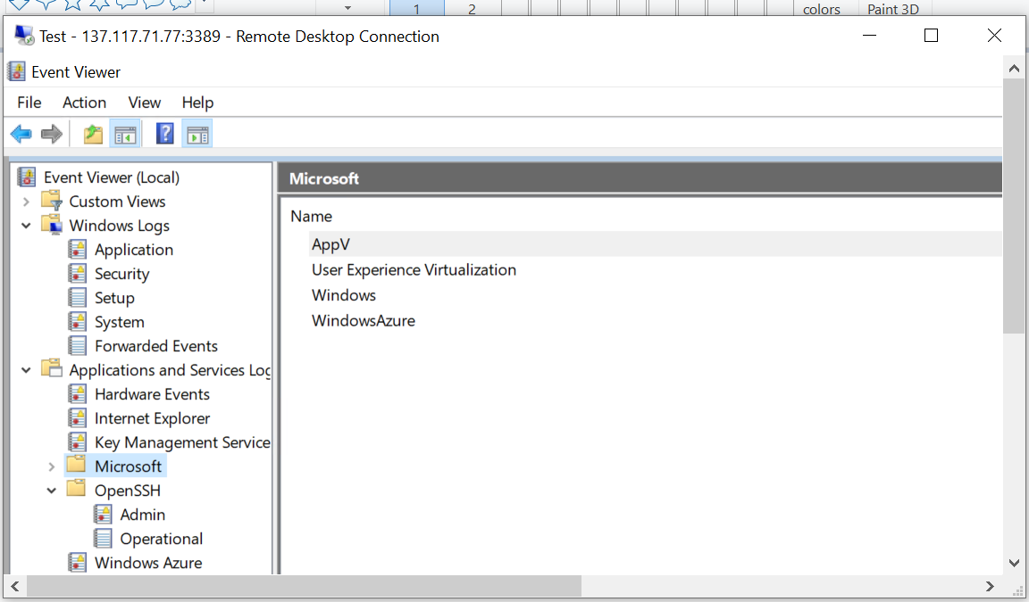

1. Deploy an application in the VM and access using the public IP

IIS is installed on machine 137.117.71.77

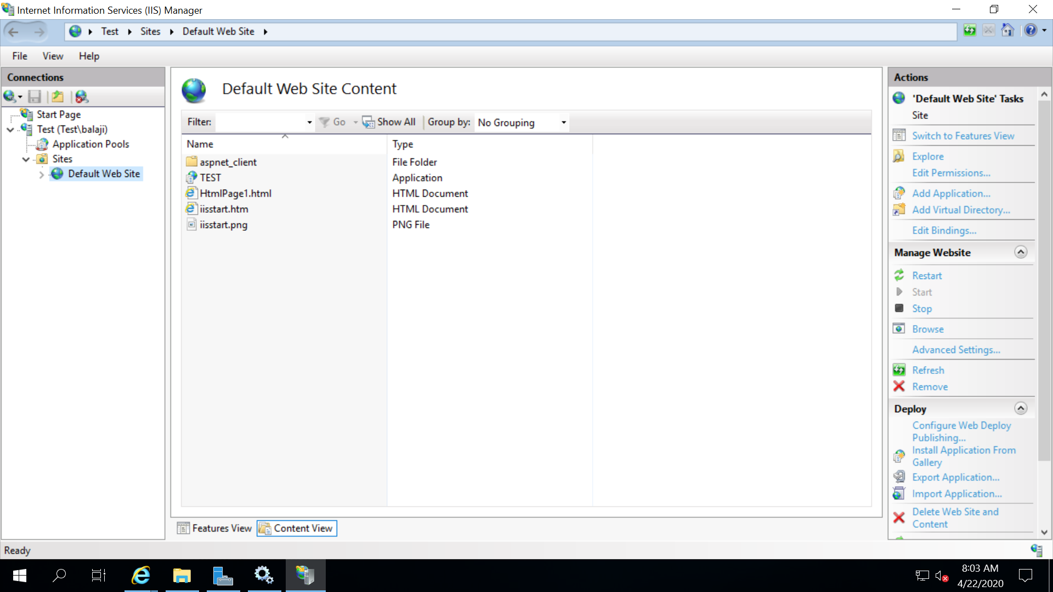

Access test website using after deployment.

<http://137.117.71.77/TEST/HtmlPage1.html>

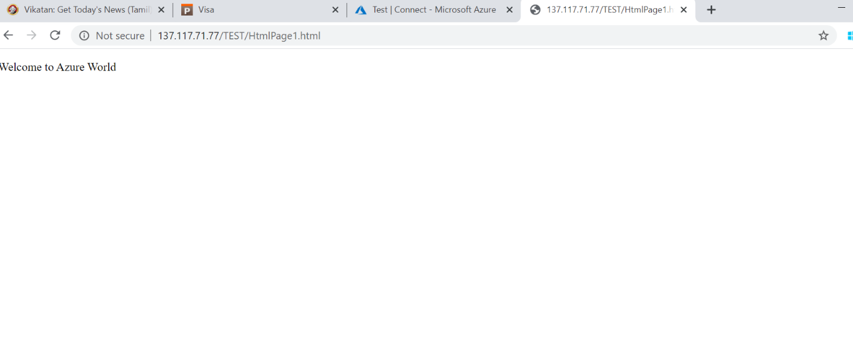

Azure App Services

1. Deploy a HTML Web Application in Azure App Services

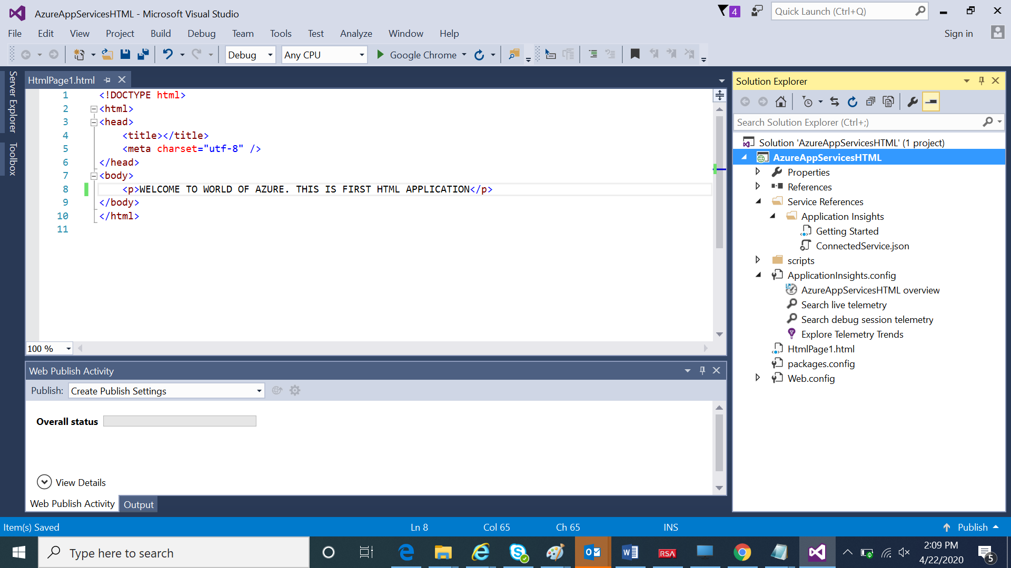

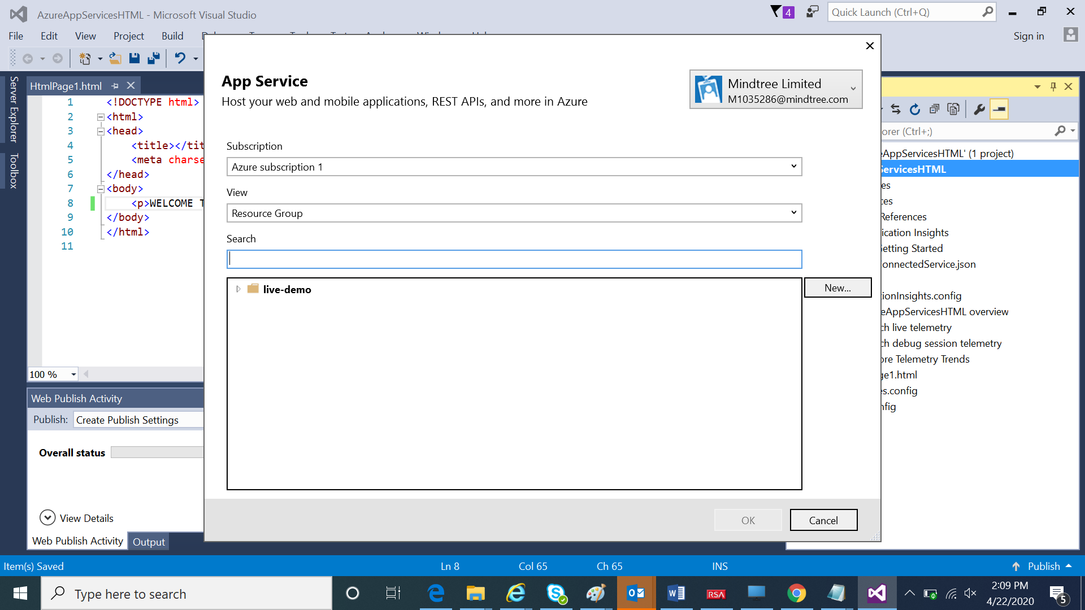

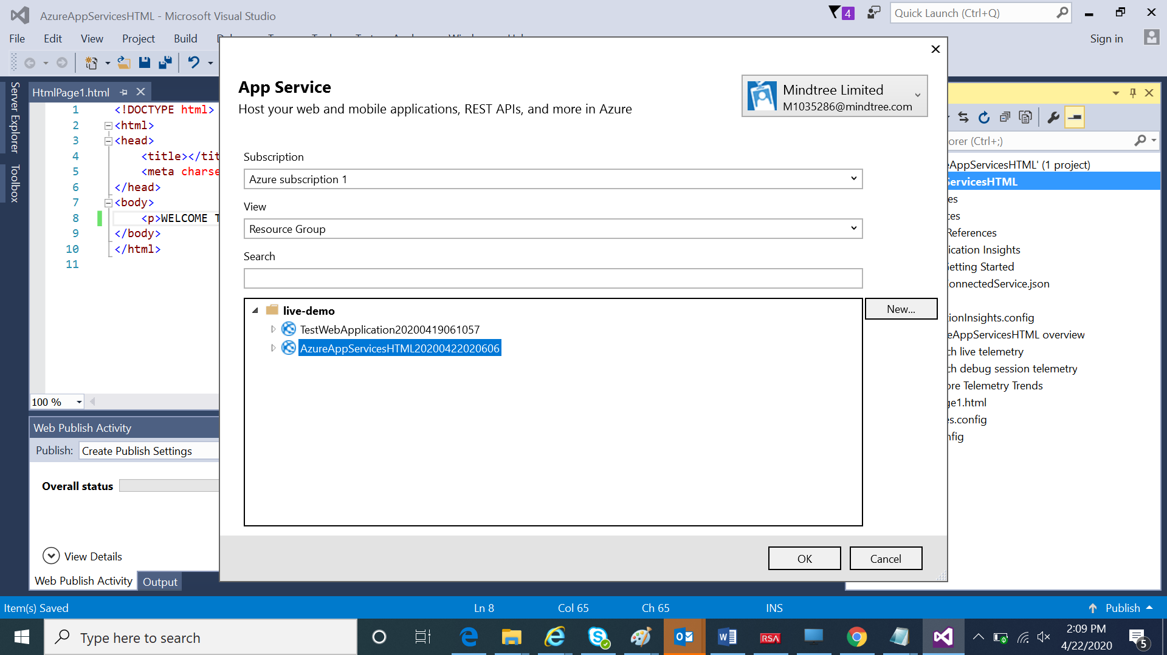

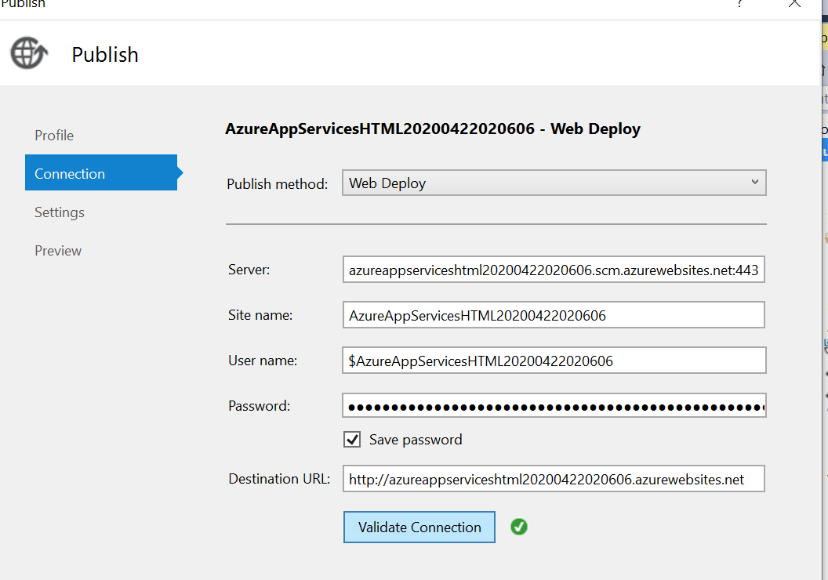

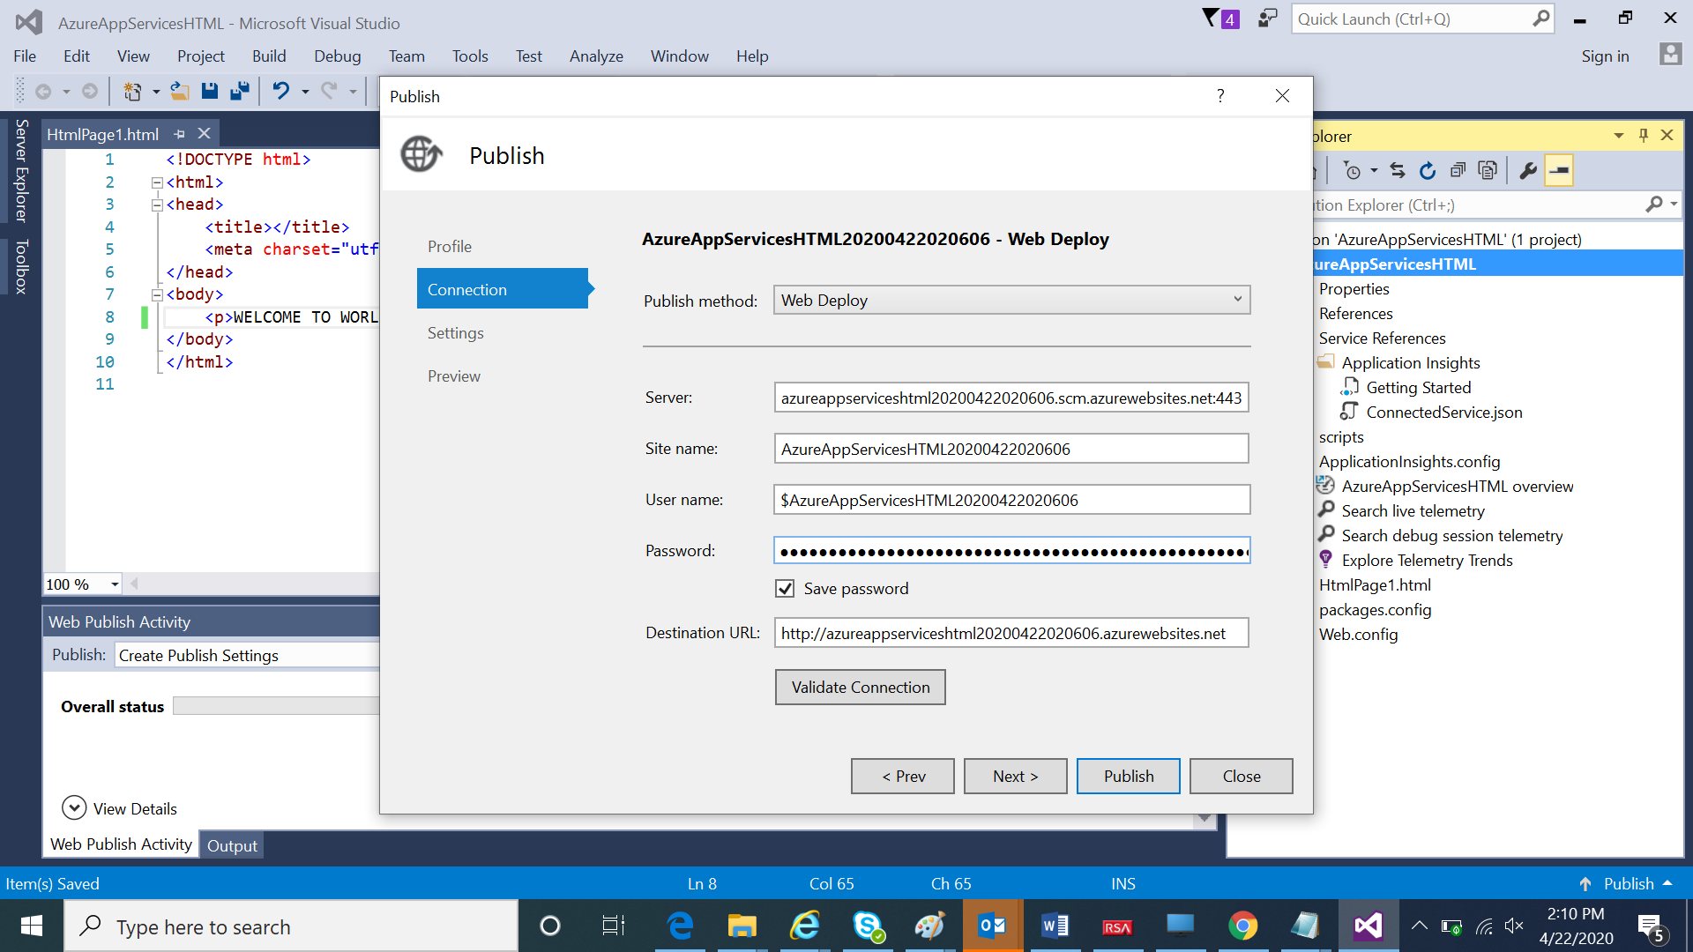

Click Publish to deploy the application into AzureApp Services

To be added later based on resource availability.

**CASE STUDY 4:**

**Write an ARM Template to deploy the azure function along with the code and other required configurations.**

Create Azure function for Httptrigger



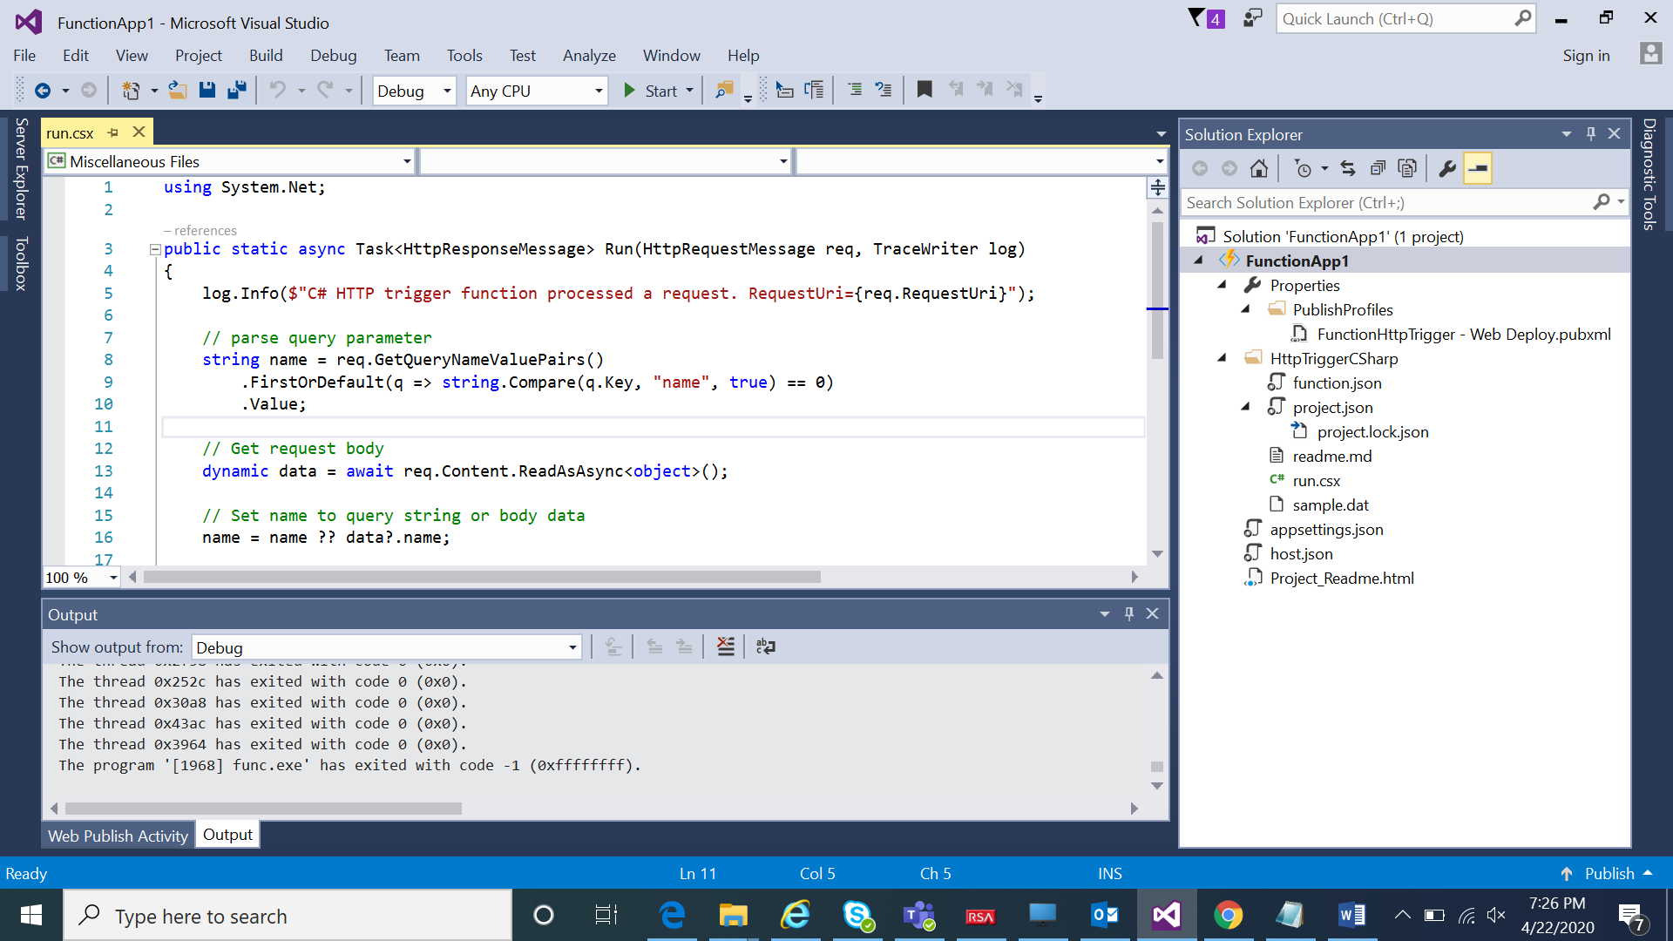

Deployed the application in to azure portal using Visual studio 2015

After deployment

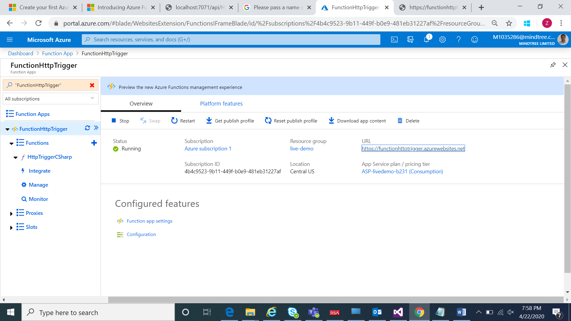

<https://functionhttptrigger.azurewebsites.net/api/HttpTriggerCSharp?name=ravi>

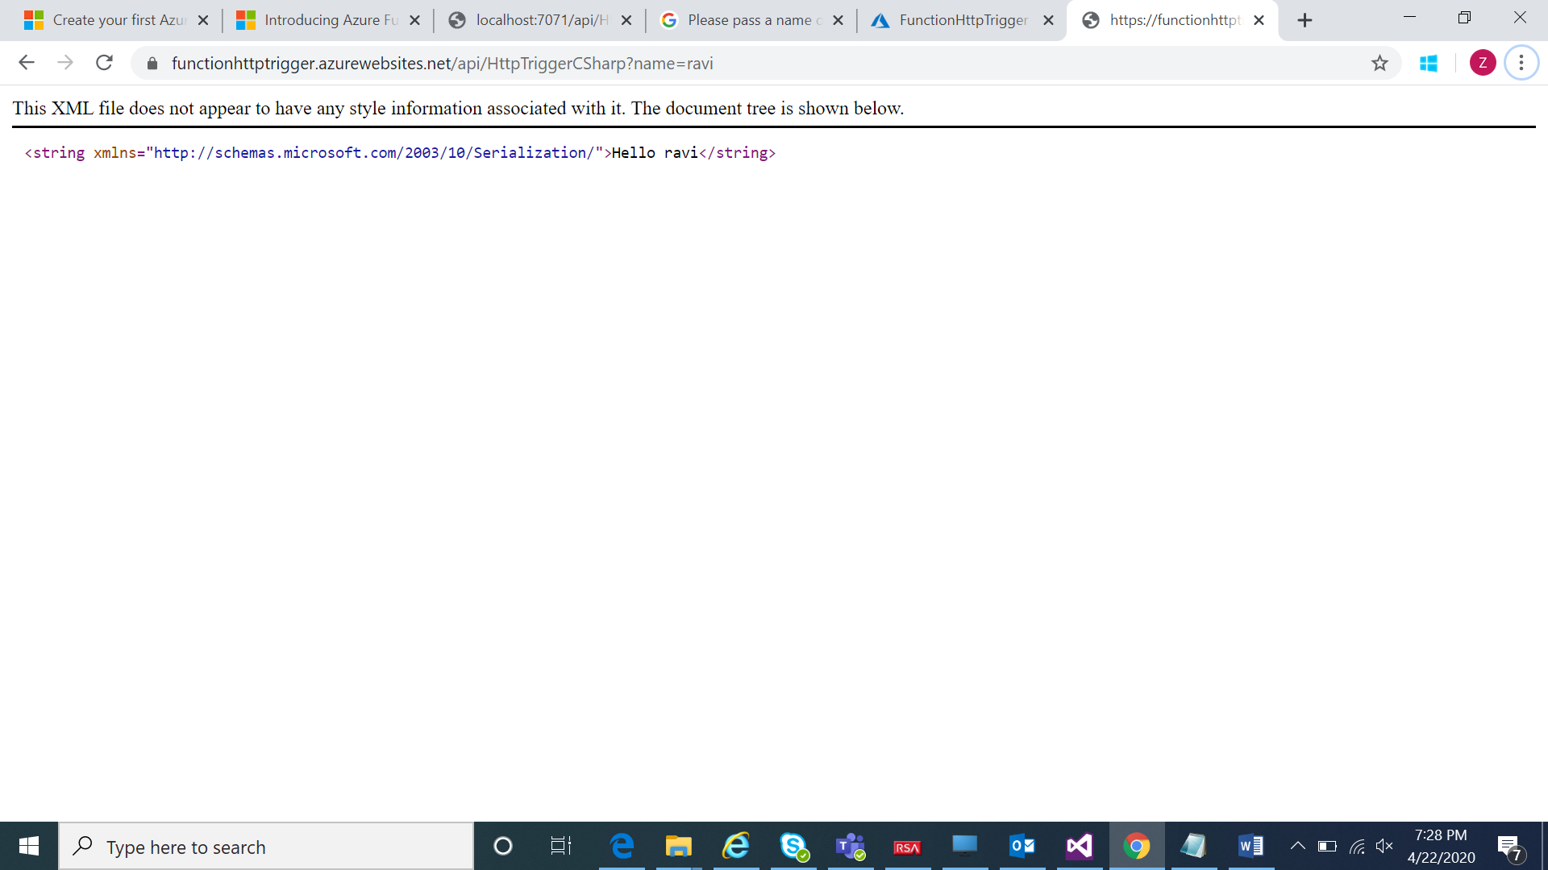

Azure Cosmos DB

1. Write an ARM Template to deploy all the Cosmos DBs

2. Integrate the above-deployed Azure function with all the Cosmos DB and retrieve the logs

ARM Template for Cosmos DB.



Screen shots after deployment.

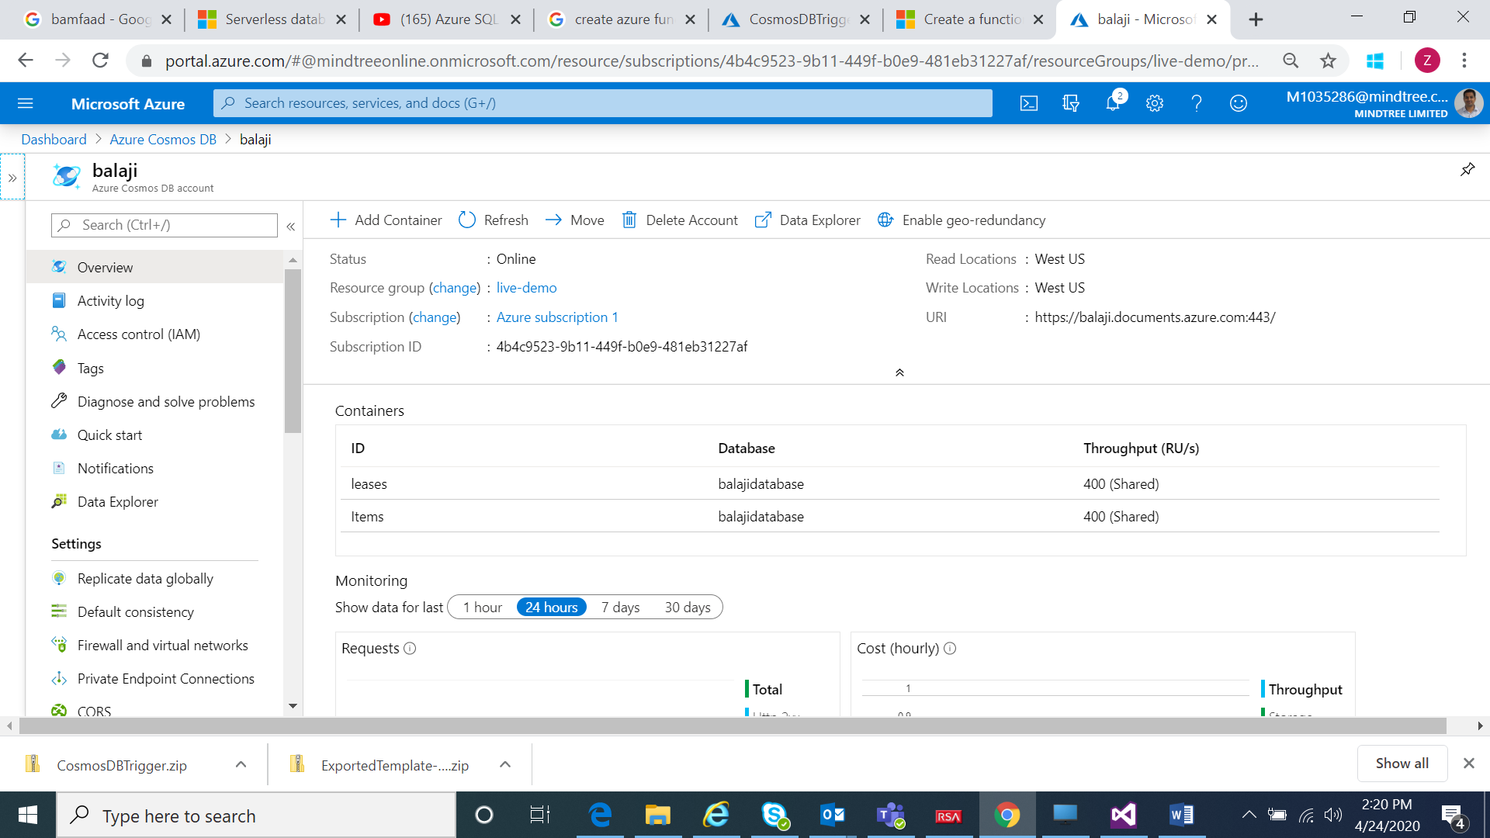

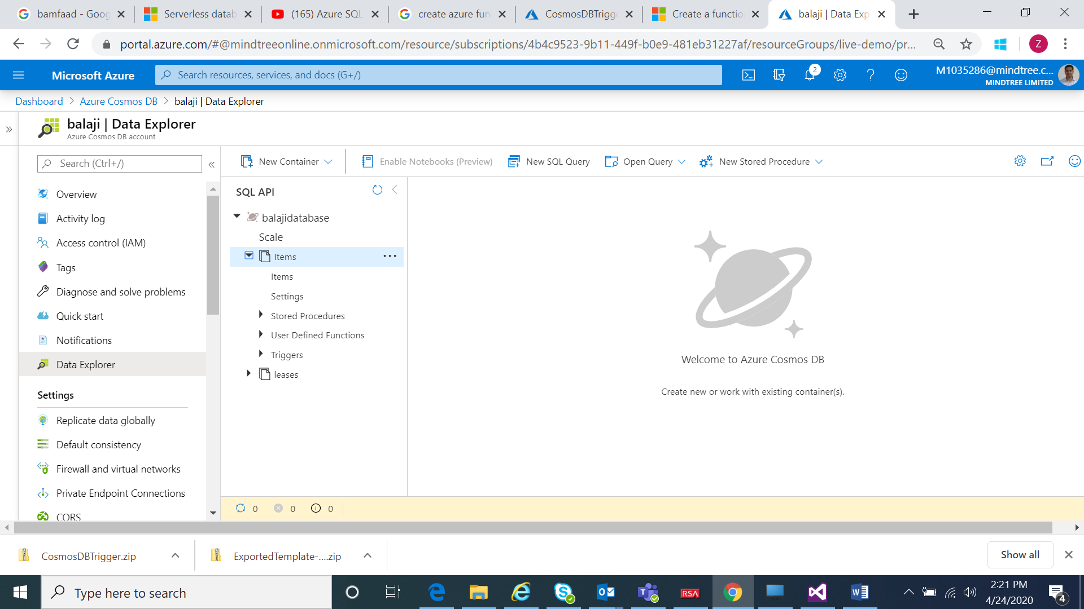

ARM Template for ComosDB Trigger function.



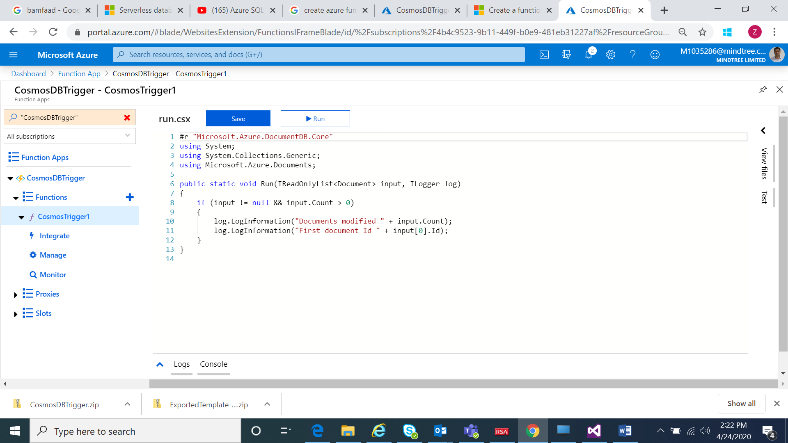

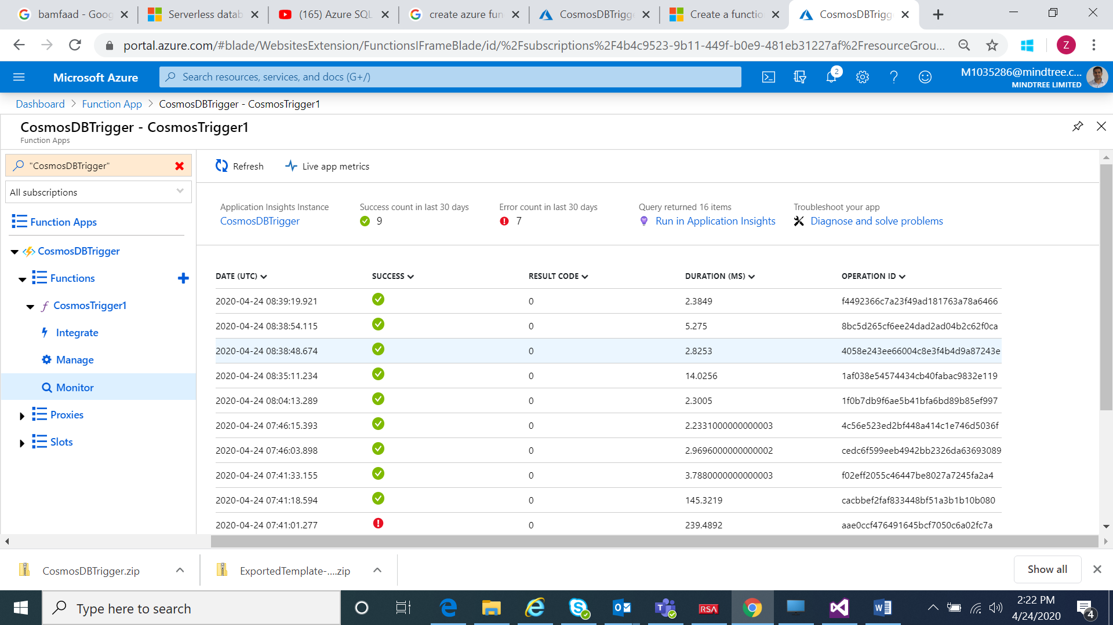

Adding one item

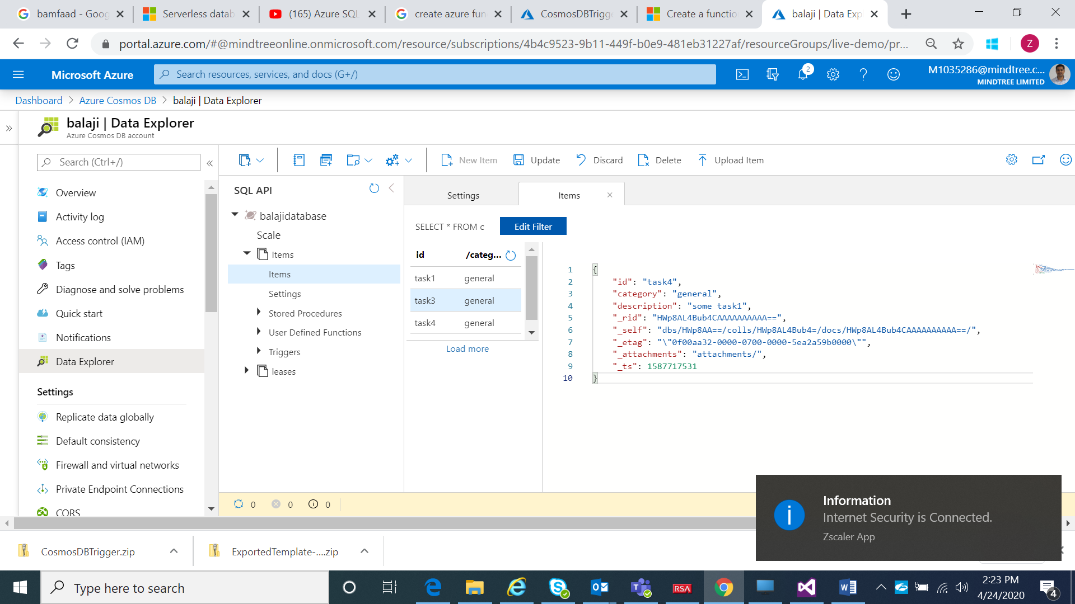

Logs are updated based on cosmos trigger

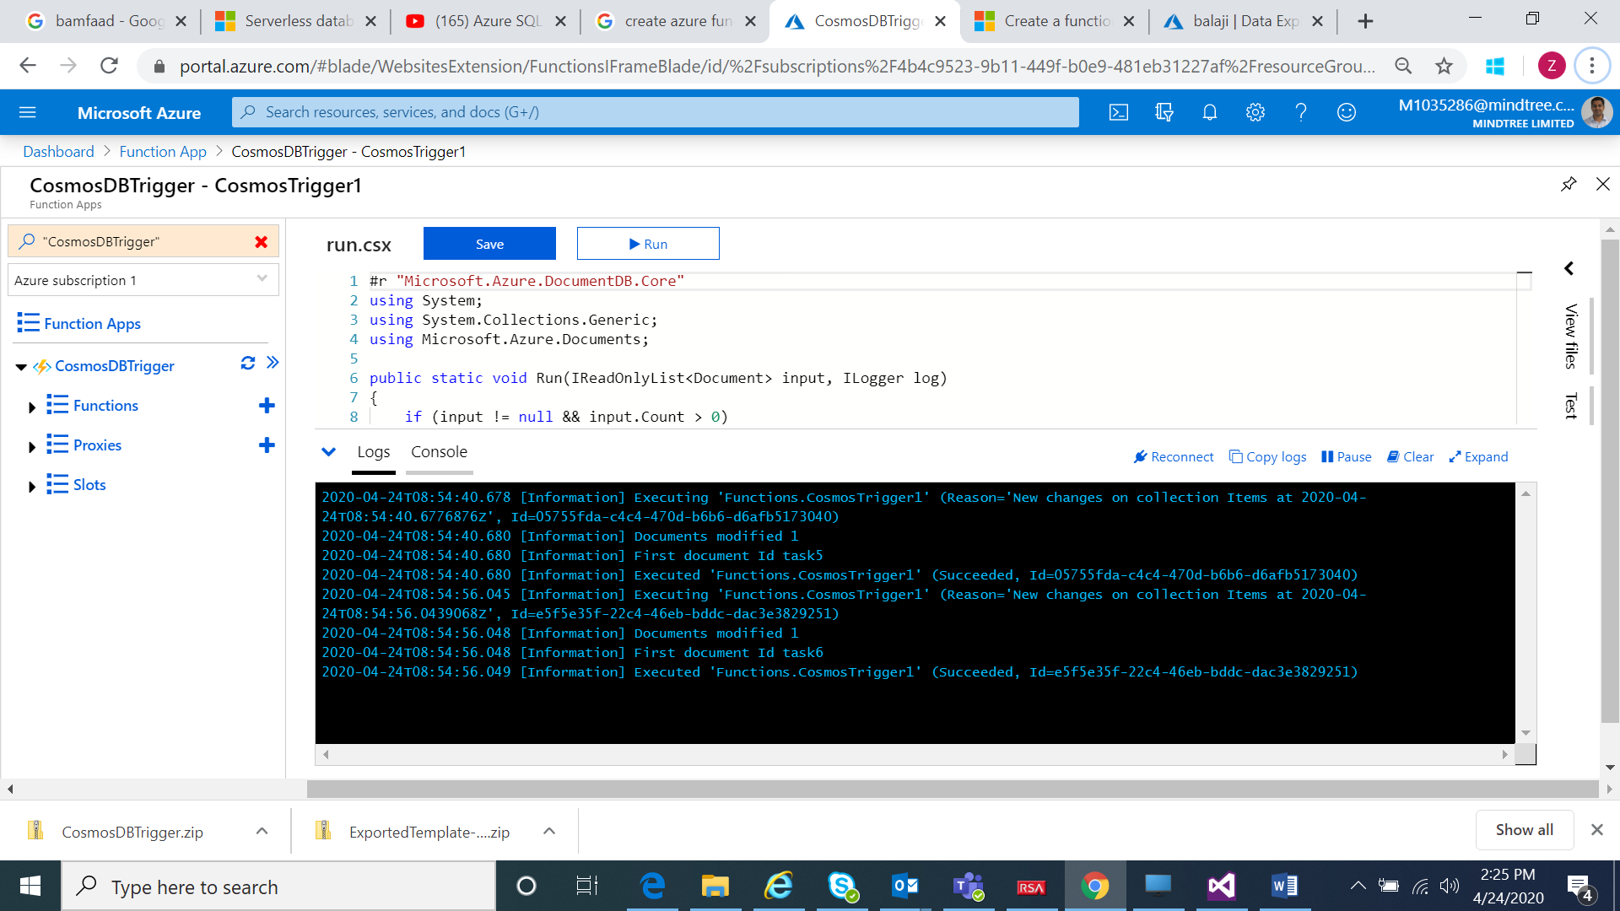

Azure Active Directory

1. Write a client application to authenticate based on OAuth grant flow.

Step1: To create Demo resource

Manifest for Demo resource:



Permissions for Demo Resource:

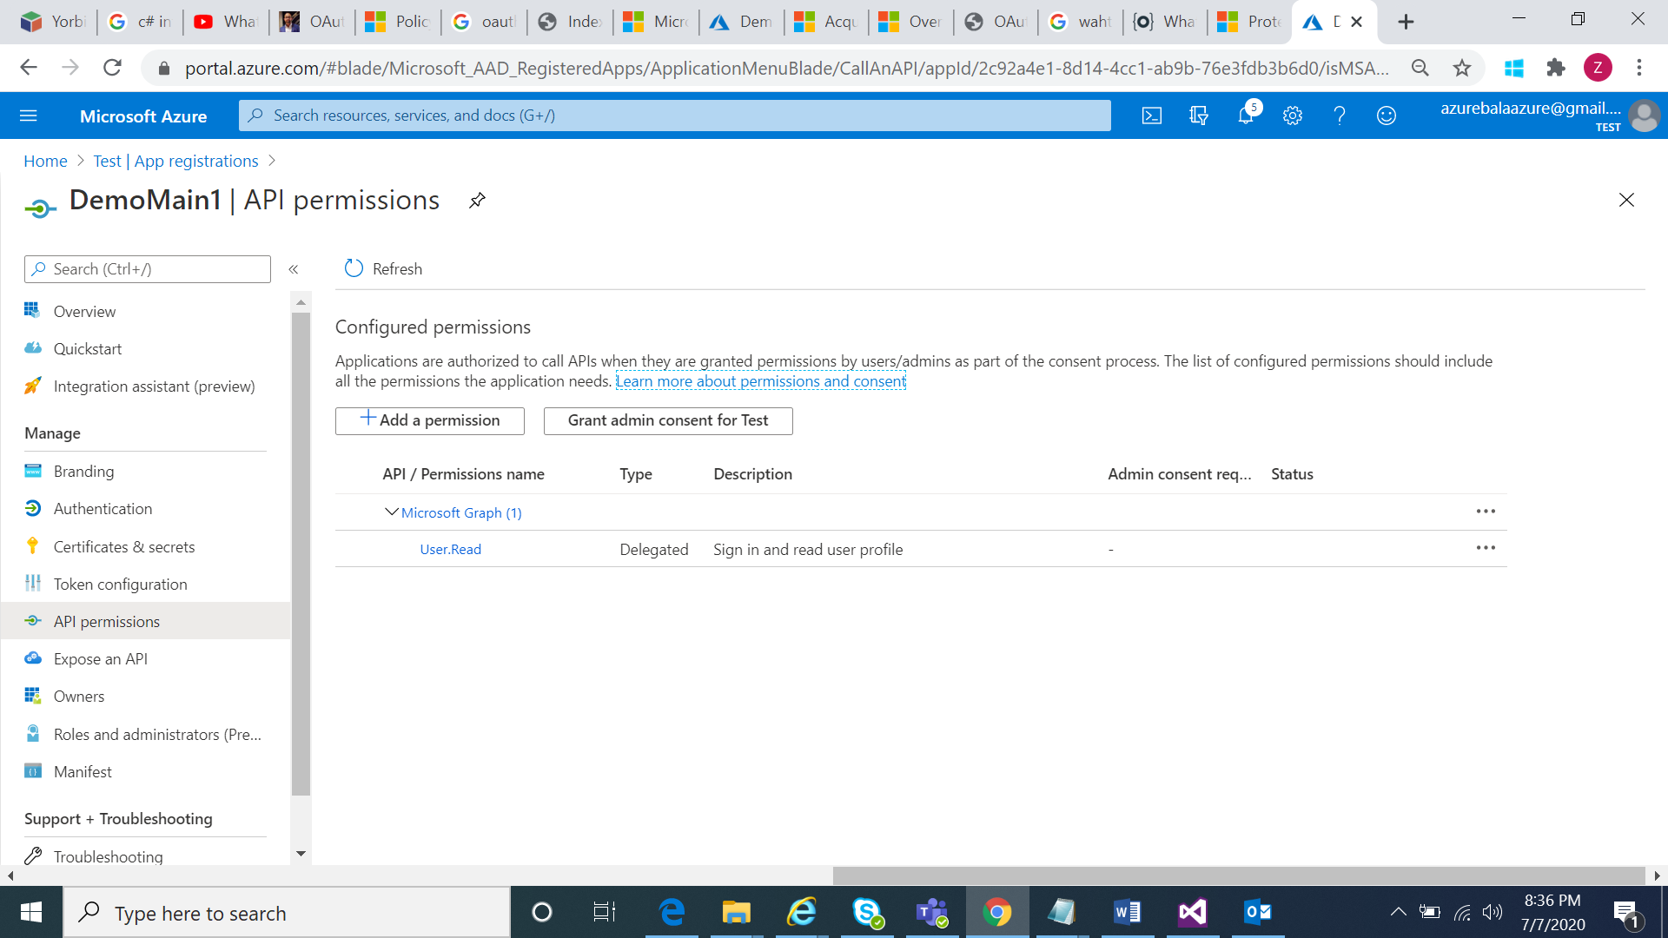

Scope for Demo Resource:

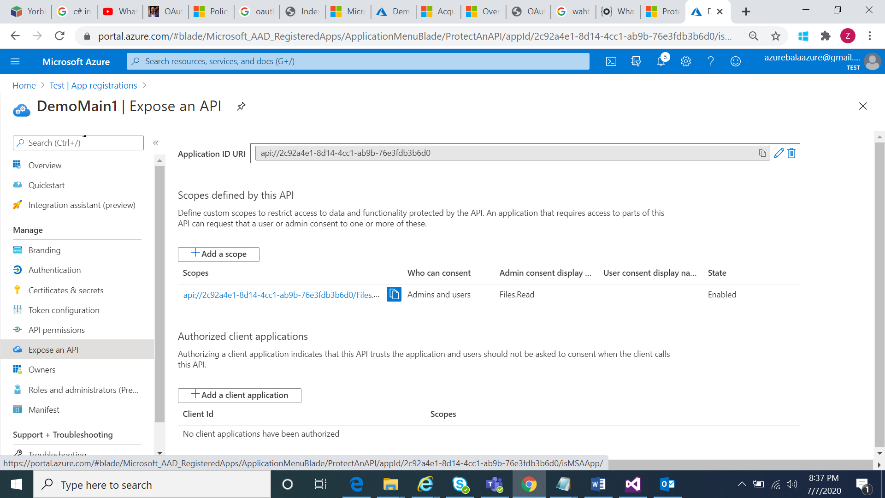

Create Developer under App Registration:

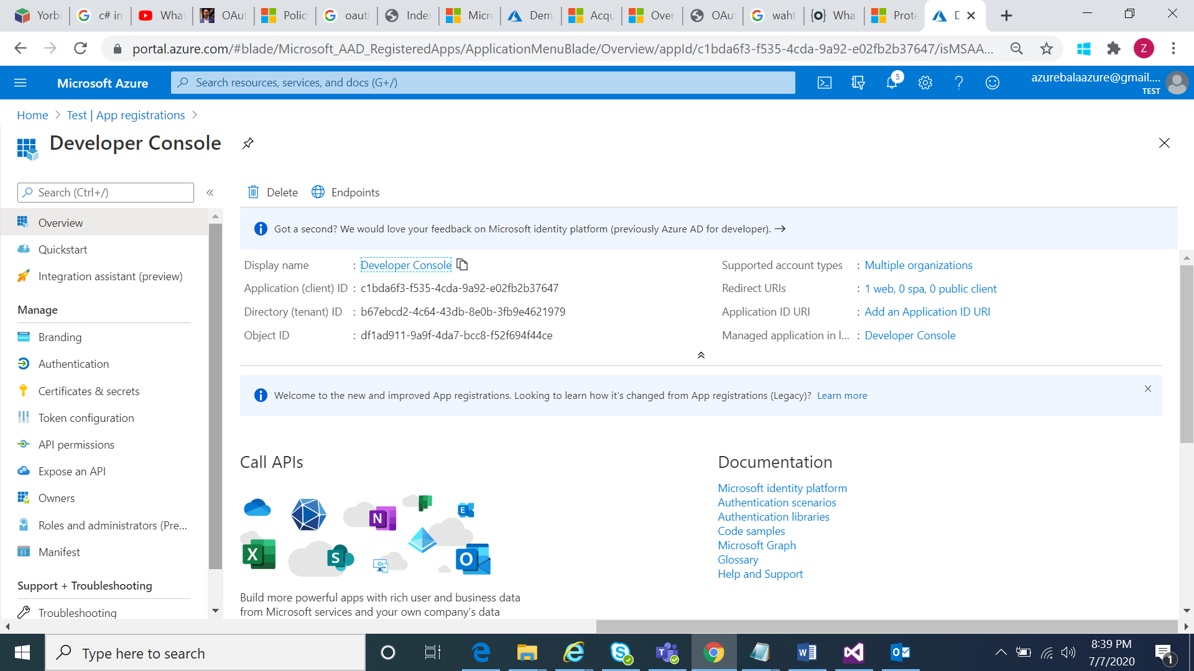

Create Secret key for Developer console:

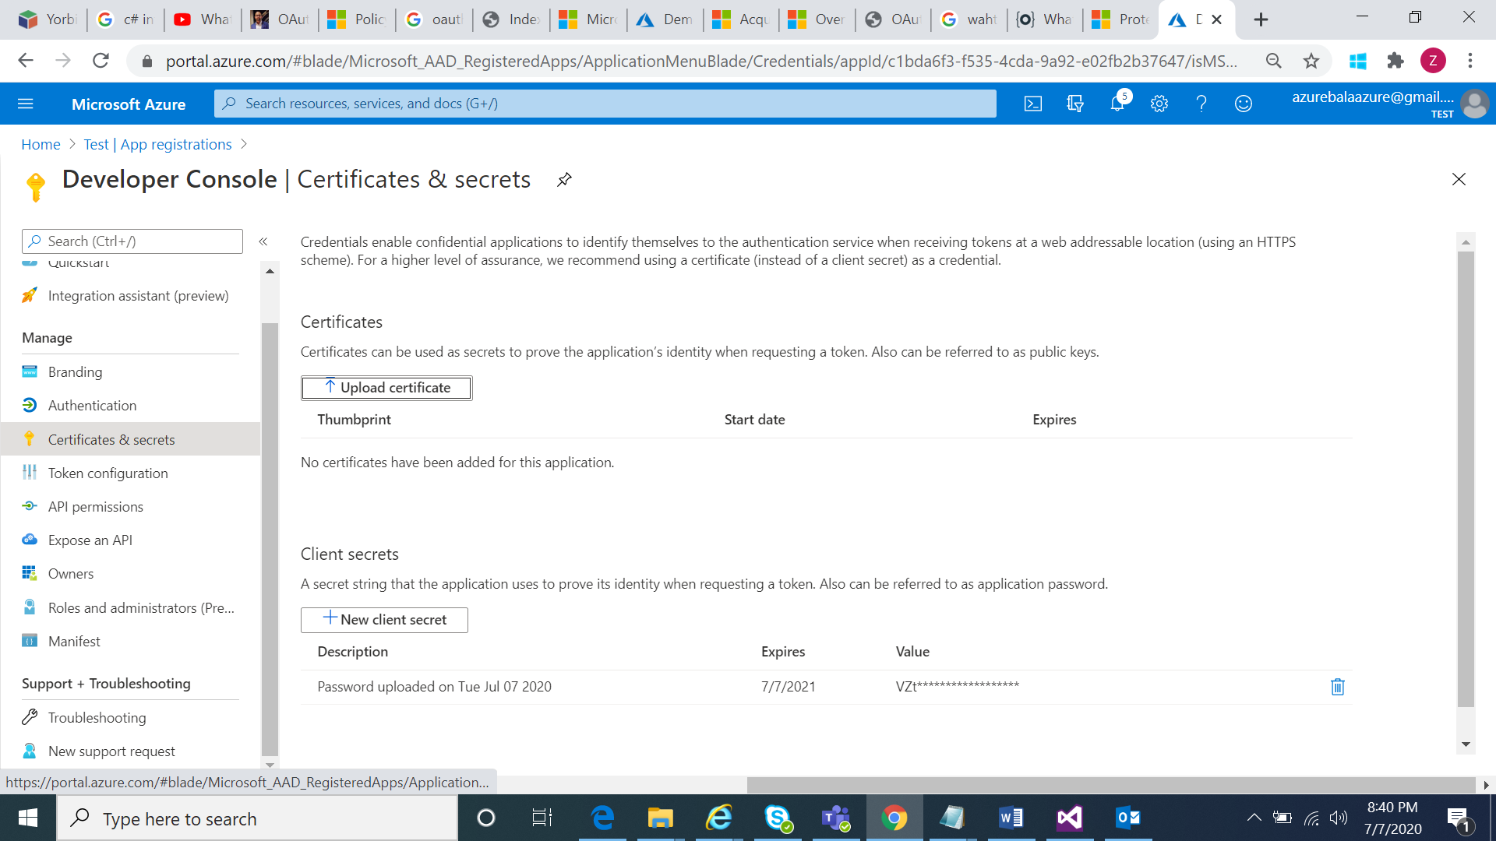

Configure Read permissions for Developer console:

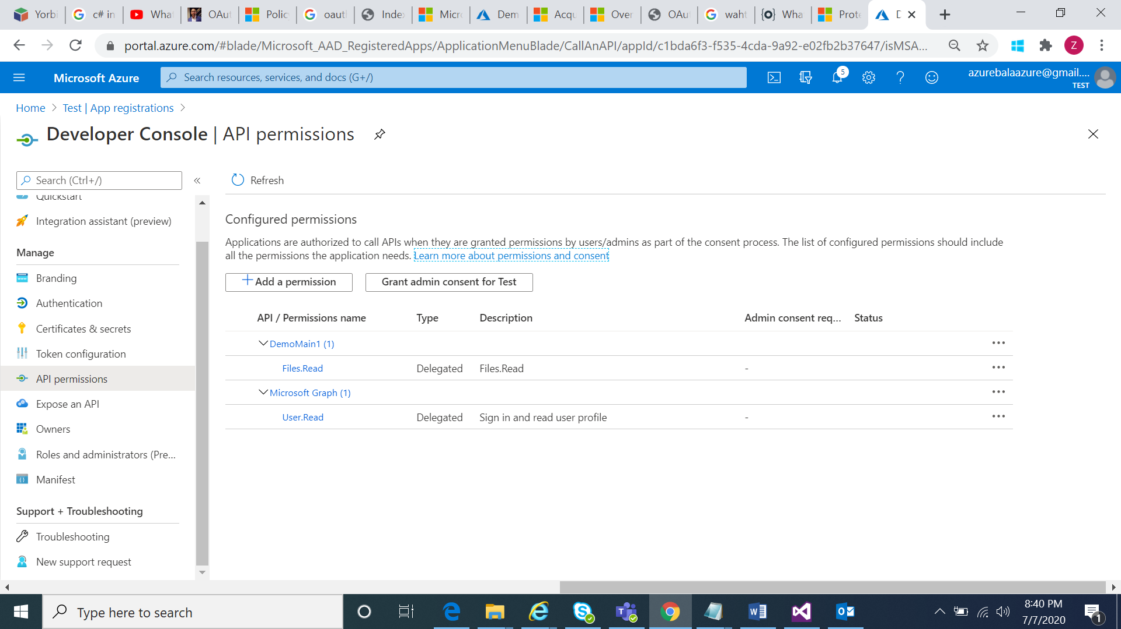

All the settings are available in the below manifest file.



## Enable OAuth 2.0 user authorization in the Developer Console

At this point, you have created your applications in Azure AD, and have granted proper permissions to allow the client-app to call the backend-app.

In this example, the Developer Console is the client-app. The following steps describe how to enable OAuth 2.0 user authorization in the Developer Console.

1. In Azure portal, browse to your API Management instance.
2. Select **OAuth 2.0** > **Add**.

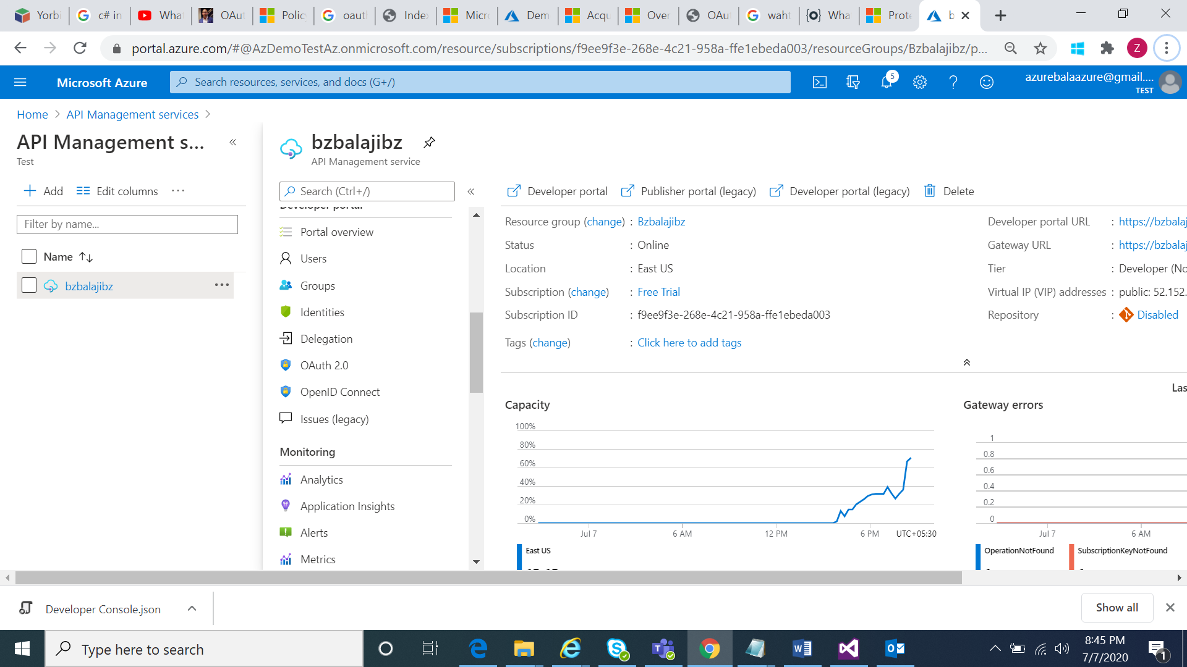

1. Provide a **Demoauth** and **Demoauth** .
2. For the **Client registration page URL**, enter a placeholder value, such as http://localhost. The **Client registration page URL** points to a page that users can use to create and configure their own accounts for OAuth 2.0 providers that support this. In this example, users do not create and configure their own accounts, so you use a placeholder instead.
3. For **Authorization grant types**, select **Authorization code**.
4. Specify the **Authorization endpoint URL** and **Token endpoint URL**. Retrieve these values from the **Endpoints** page in your Azure AD tenant. Browse to the **App registrations** page again, and select **Endpoints**.
5. Copy the **OAuth 2.0 Authorization Endpoint**, and paste it into the **Authorization endpoint URL** text box. Select **POST** under Authorization request method.
6. Copy the **OAuth 2.0 Token Endpoint**, and paste it into the **Token endpoint URL** text box.
7. Next, specify the client credentials. These are the credentials for the client-app.
8. For **Client ID**, use the **Application ID** of the client-app.
9. For **Client secret**, use the key you created for the client-app earlier.
10. Immediately following the client secret is the **redirect_url** for the authorization code grant type. Make a note of this URL.
11. Select **Create**.

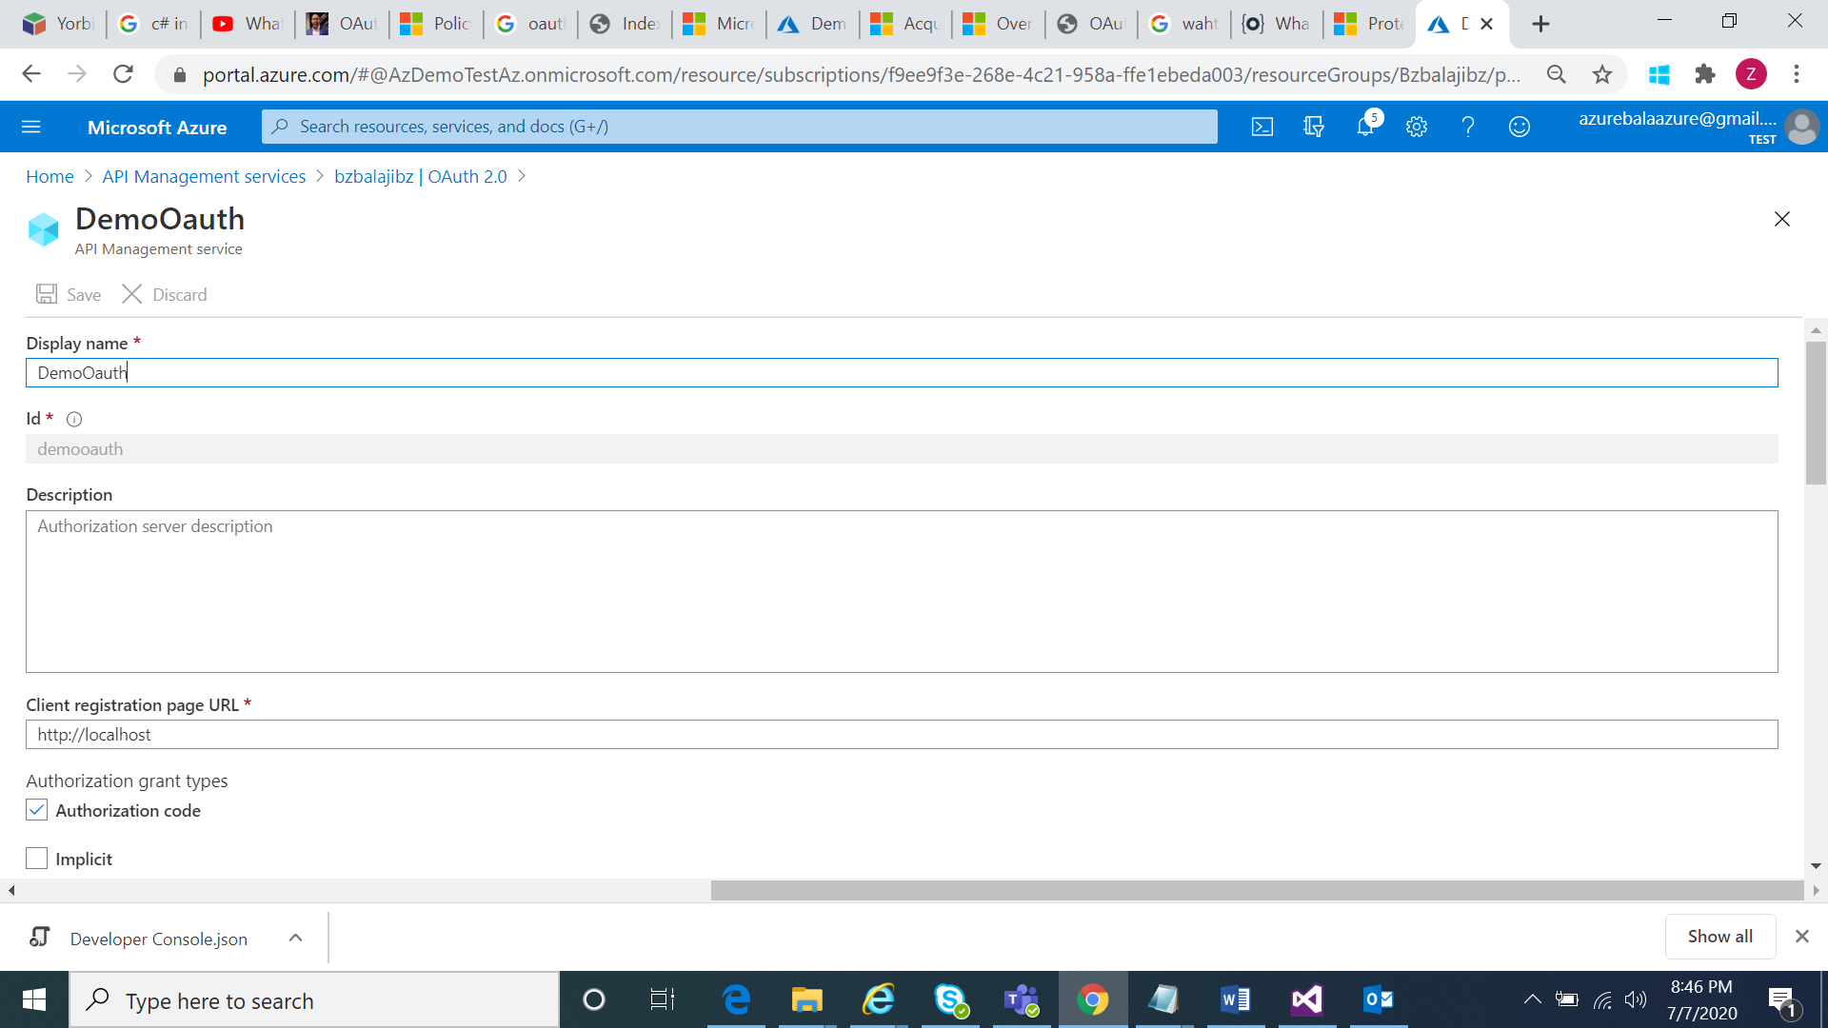

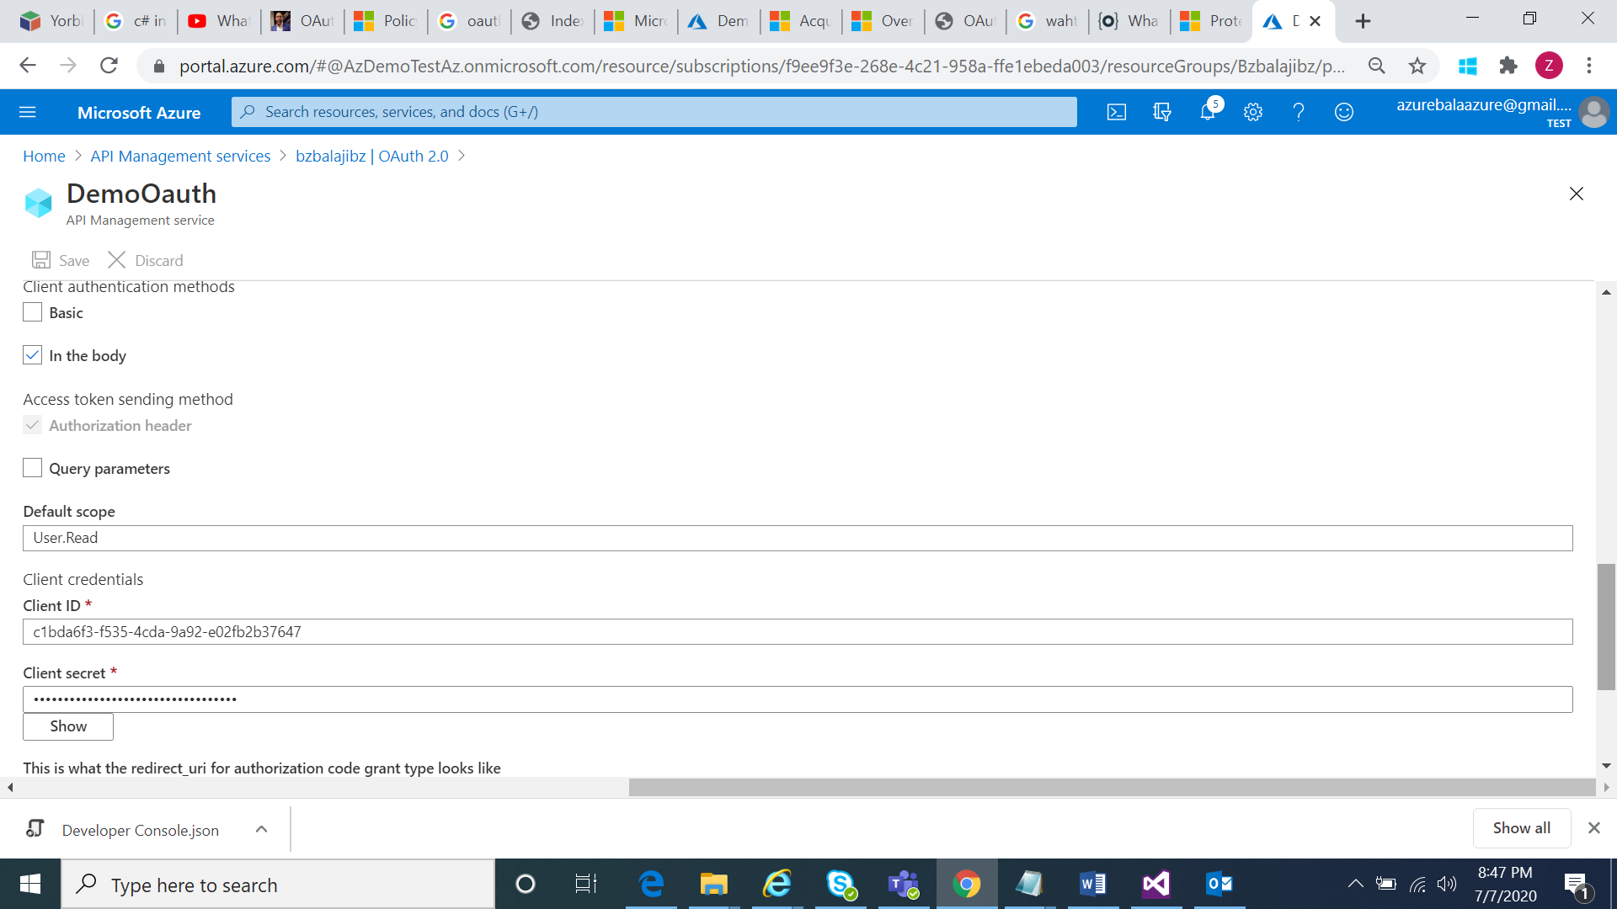

1. Go back to your client-app registration in Azure Active Directory and select **Authentication**.
2. Under **Platform configurations** click on **Add a platform**, and select the type as **Web**, paste the **redirect_url** under **Redirect URI**, and then click on **Configure** button to save.

Setup oauth for Echo Api

1. Browse to your API Management instance, and go to **APIs**.
2. Select the API you want to protect. For example, Echo API.
3. Go to **Settings**.
4. Under **Security**, choose **OAuth 2.0**, and select the OAuth 2.0 server you configured earlier.
5. Select **Save**.

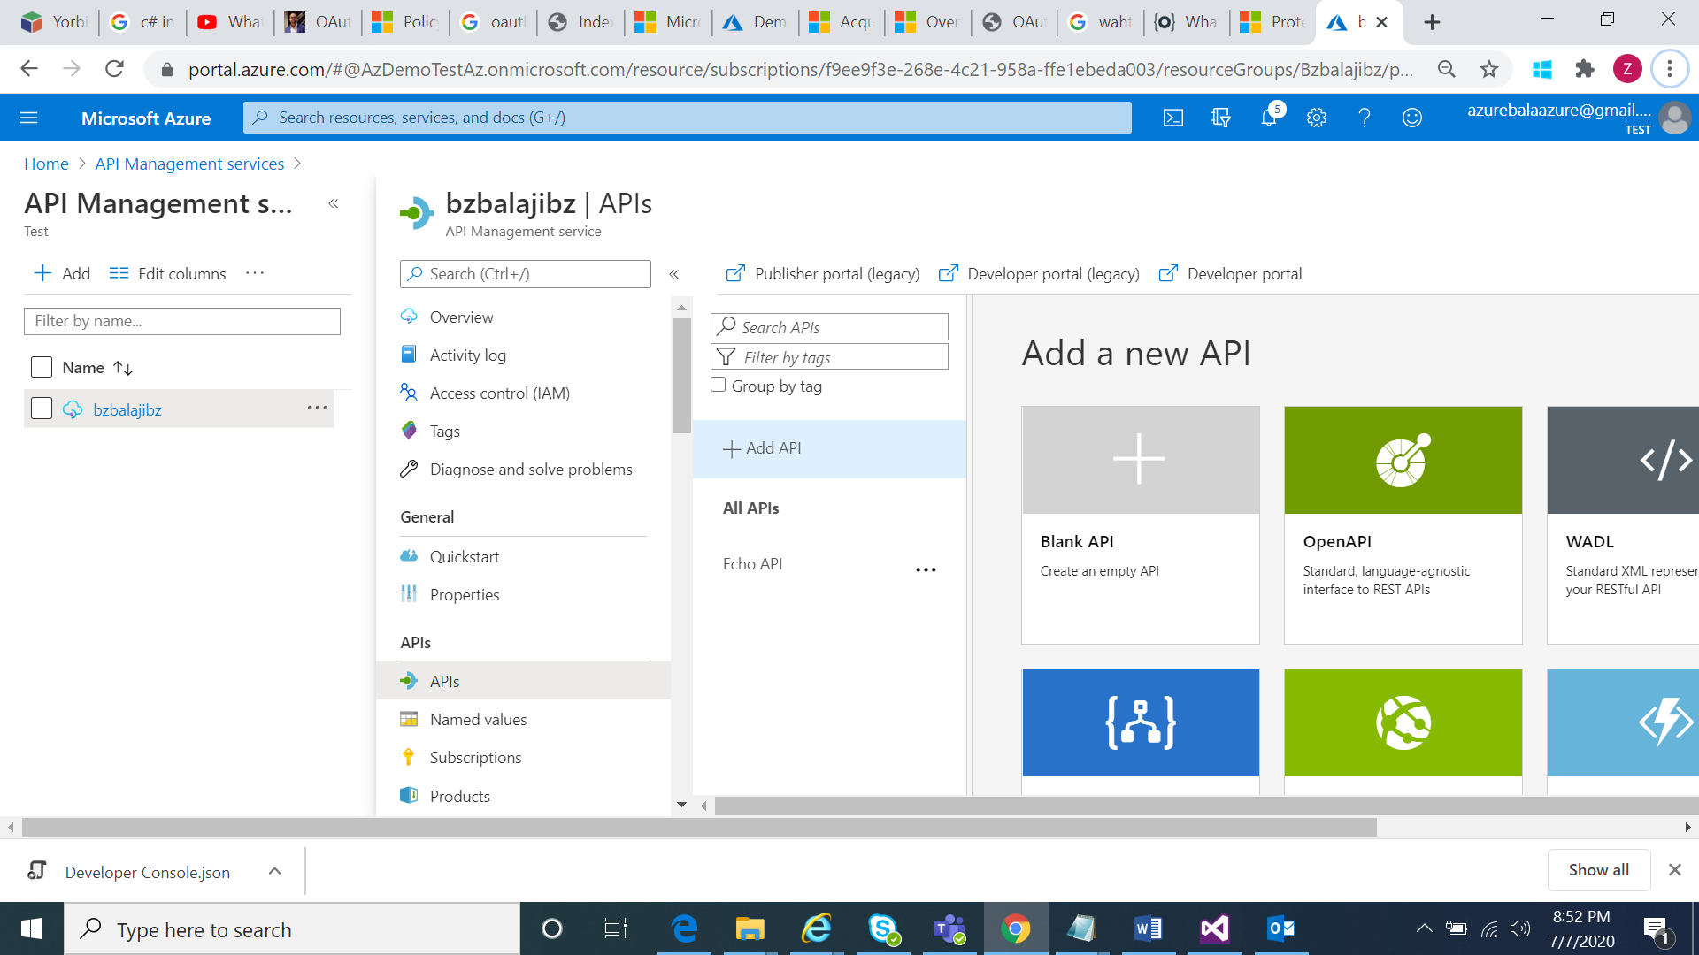

Select Demooauth from drop down

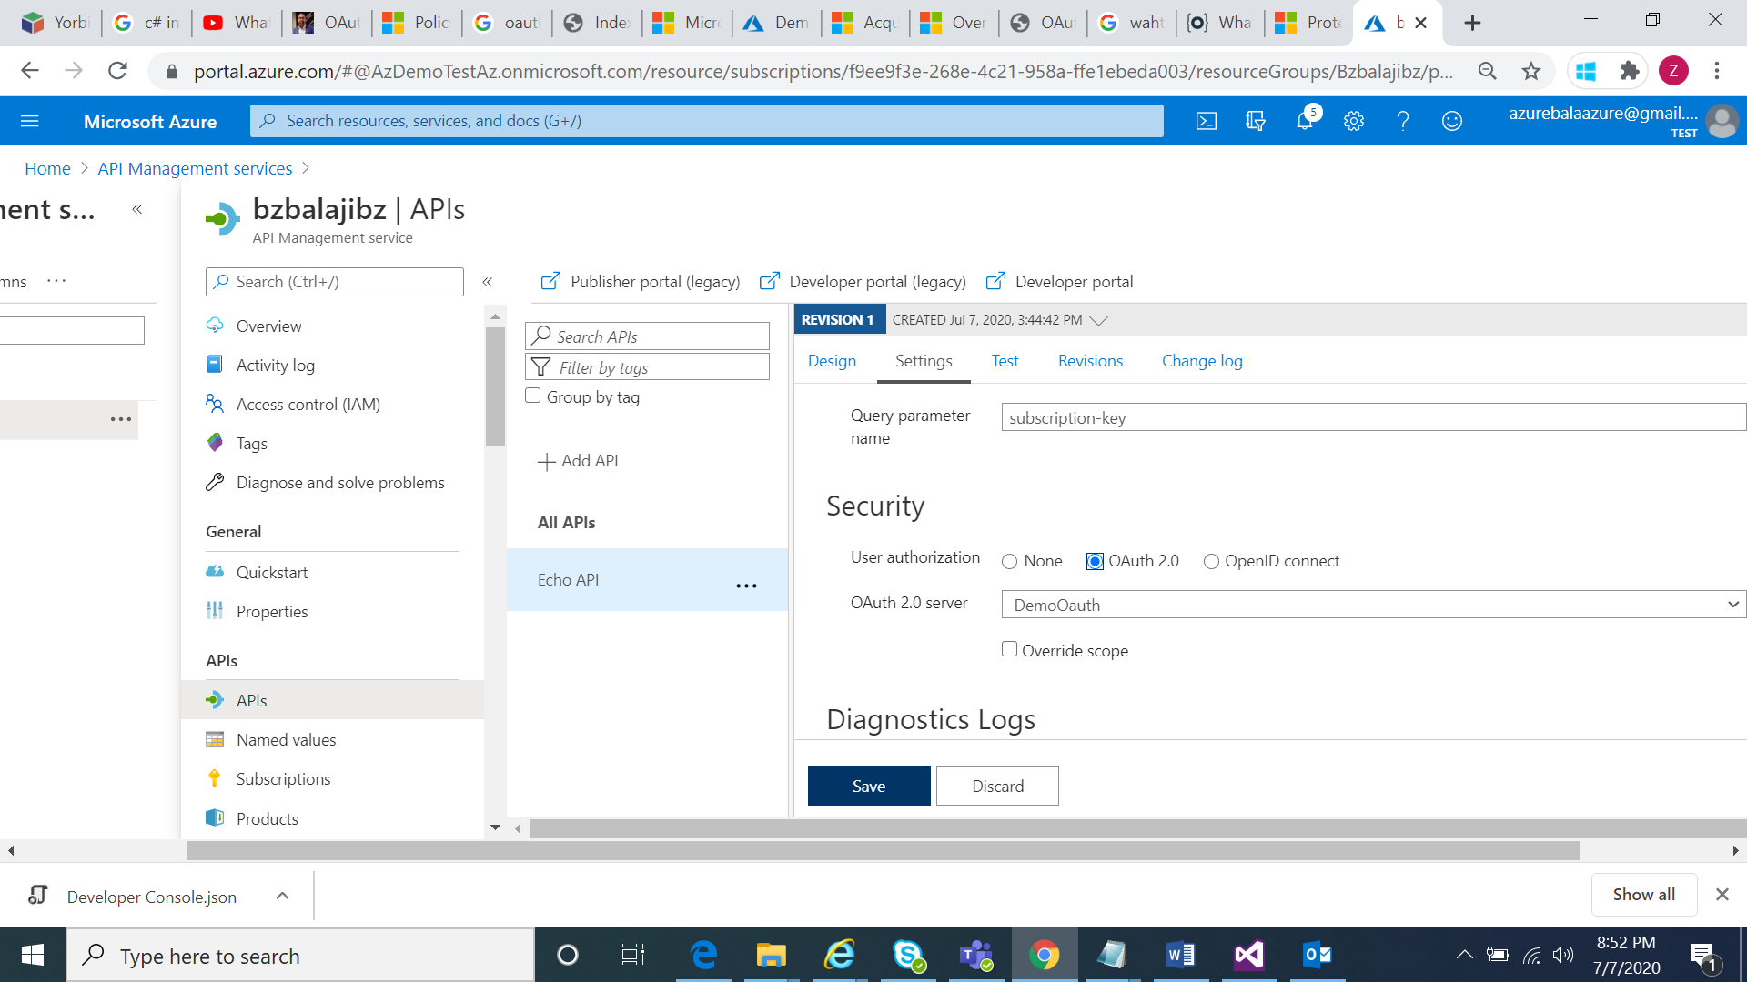

Test after adding oauth and test the Api.

